## UNDERSTANDING AND ANALYSING TYPES OF PARADOXES

**ABSTRACT**

Paradoxes are fascinating statements or assertions that negate ordinary logic;

they also depict the problems encountered when trying to reason. In the paper, we

look at paradoxes of various types -there are four types: a) logical paradoxes b)

semantic paradoxes, c) ethical paradoxes, and d) empirical paradoxes. First, there

are the classically known examples: first, the Liar Paradox, and second, Russell's

Paradox from which we discuss implications they had on formal logic as well as set

theory. The paper also speaks about many paradoxes in ethics-the paradox of the

unexpected hanging is one example, which would challenge the intuition as

opposed to the rationality of things. It is also very interesting for our case,

discussing some empirical paradoxes that come up in scientific contexts because it

can show us how apparently troublesome paradoxes can lead us to greater insights

and further advancement. A comprehensive analysis will be conducted,

attempting to make clear the importance of paradoxes in philosophy,

mathematics, and science, with conclusive implications-in that embracing

contradictions can better and advance critical thinking and innovation.

A paradox is a statement, situation, or concept that appears to contradict itself or

defy common sense, yet may reveal a deeper truth or insight upon closer

examination.

**KEYWORDS:**

THE LIAR PARADOX

ZENOS PARADOX

MONTY HALL PARADOX

SORITES PARADOX

GRAND FATHER

PARADOX PARADOX OF

CHOICE FERMI PARADOX

RUSSELLS PARADOX

TWIN PARADOX

FRIENDSHIP PARADOX

BARBER PARADOX

NEWCOMBS PARADOX

INTRODUCTION:

Paradoxes have always possessed an inquisitive and intellectual grip on

philosophers, mathematicians, and scientists, often used as thought experiments

which challenge the mind's concept of logic, language, and reality. A paradox

usually states a situation to which intuitive reasoning leads one to conflicting

conclusions, thereby creating a motivation for a deeper understanding of the

underlying principles which govern our thought processes. Thus, this paper shall

engage with several key paradoxes each describing particular levels of

complexity in their domains.

The Liar Paradox may rank as the most well known of the logical paradoxes. Since it

claims itself to be false, in some form or another we have not yet really discovered

truth. Zeno's Paradox challenges our comprehension of motion and continuity based

on showing that an infinitely large number of steps have apparently contradictory

conclusions for being able to travel a given distance. Monty Hall paradox is

developed from a chance game. It often turns out how the natures of the decision

making regarding uncertainty can be quite paradoxical.

It is in vagueness that the question of the Sorites Paradox seems to raise some issues

with regard to just when a heap of sand ceases to be considered a heap, probing

more deeply the boundaries of categories. In the case of the Grandfather

Paradox, time travel creates one of its most interesting sets of puzzles, raising an

issue over what the outcome would be if events which had taken place were allowed

to be altered. Finally, the Paradox of Choice exemplifies the psychological burdens of

being faced with too many options such that greater choice can itself lead to greater

dissatisfaction.

The Fermi Paradox is a contradiction in astrophysics: the probability of

extraterrestrial life is high, yet no evidence of it exists, thus prompting an

exploration into our place in the universe. Russell's Paradox shakes up set theory as

a whole because it revealed that naive definitions of a set are actually

inconsistent, while the Twin Paradox of relativity challenges how we understand

time and what we consider to be simultaneous.

Social dynamics are not immune to paradoxical reasoning; the Friendship Paradox

shows how individuals typically have

fewer friends than their friends do, which leads to questions about social networks.

The Barber Paradox is a selfreferential riddle that further complicates our notions

of self-inclusion in categories, and Newcomb's Paradox presents a dilemma in

decision theory, questioning rational choice in predictive scenarios.

This paper will unpack these paradoxes in-depth, discussing implications and

insights into logical reasoning, philosophical inquiry, and scientific understanding.

With all these cases presented, we can show that paradoxes are important tools for

critical thinking and innovation as well as an even deeper understanding of the

complexities surrounding our world.

Importance of Research on Types of Paradoxes

Research on the various types of paradoxes has immense value across several

disciplines, thus aiding in a better understanding of logic, language, philosophy,

mathematics, and human behavior. Here are a few crucial reasons why this

research is so important:

Logical Structures are Clarified

There are logical, semantic, and ethical paradoxes which, in their way, show

structures that exist below the surface of logic thinking. The study of paradoxes can

help discover where flaws and ambiguities might be found in the logic systems, thus

advancing theories and frameworks.

Formulating Philosophical Thinking

Paradoxes tend to raise some of the most fundamental questions about truth,

existence, and knowledge. Researching many paradoxes promotes philosophical

discussion, encourages critical examination of concepts such as identity, time, and

free will, and ultimately enriches our understanding of philosophical thought.

Improving Mathematical Theories

Some of the paradoxes in mathematics are Russell's Paradox and Zeno's Paradoxes,

which historically were used to create breakthroughs in the theories and practice of

mathematics. Contributions here help in formulating more coherent mathematical

theories and also towards the analysis of fundamental problems in mathematics.

Better models for decisions

Paradoxes regarding choice and probability such as the Monty Hall Problem and

Newcomb's Paradox are very fascinating studies of human decision-making

processes. This research might help us know more regarding cognitive biases and

further better decision-making models in economics, psychology, and behavioral

science.

Encourage Interdisciplinary Collaboration

The study of paradoxes cuts across disciplines-from philosophy to mathematics and

psychology and cognitive science. This cross-disciplinary approach helps foster

cooperation and provides innovative insights and solutions from the best of each

field.

Investigation of Ethical Considerations

Ethical paradoxes, for example, in the Paradox of the Unexpected Hanging, challenge

even the most sound moral intuition and raise issues about both justice and

rationality; research into such paradoxes can lead to more delicate ethical theories

and a deep understanding of the nature of moral dilemmas.

Applications to Science

Science paradoxes like the Fermi Paradox inspire searching into the nature of the

universe and what conditions favor life.

The scientific endeavor into these paradoxes promotes scientific exploration that,

again, generates more hypotheses, which leads to research in matters of astrophysics

and biology and further.

Improve Educational Tools

Paradoxes can be used as tools of effective teaching, allowing the use of paradoxical

ideas in engaging students' critical

thinking. The types of paradoxes researched by experts would help in using these

strategies to create educational settings where learners can become more analytical

and intellectually inquisitive.

Cultural Reflection Facilitation

The majority of paradoxes occur due to cultural and social events. These paradoxes,

which are reflective of the complexity of human existence, allow for the in-depth

exploration of societal beliefs, norms, and values that contribute to cultural

dynamics.

All these are significant

**IMPORTANCE OF EACH PARADOX**

Liar Paradox

The Liar Paradox is fundamental for understanding self-reference and language

truth. It explains difficulties in defining truth in natural language, which then make

philosophers and logicians doubt the foundations of semantic theory and the

coherence of languages.

Zeno's Paradox

Zeno's Paradox is very significant in the study of motion and continuity. It raises deep

questions about infinity and the

nature of space, which affect the development of calculus and philosophical inquiry

into the foundations of mathematics and physics.

Monty Hall Para dox

The Monty Hall Paradox is crucial to show the counterintuitive aspect of probability

and choice theory. It is one among the practical applications of Bayesian inference

and demonstrates how often the tendency of human instincts to pass intuitive

judgments leads them to flawed answers when the issue is vague.

Sorites Paradox

The Sorites Paradox is concerned with the problem of vagueness and boundary

conditions in language and logic. It helps to explore how we sort concepts into

categories and the implications of vagueness in discussions on philosophical and

linguistic grounds.

Grandfather Paradox

The Grandfather Paradox is important in discussions concerning time travel and

causality. It poses questions regarding time, determinism, and what occurs if past

events are altered, hence generating great debate in both philosophy and

theoretical physics.

Paradox of Choice

This provides some insight into how much excess choice creates a sense of anxiety

and freezes people, unable to choose anything.

The insights generated here would be useful for consumer behavior, marketing, and in

mental health practices because choices are presented very differently under its

perspective.

Fermi Paradox

This leads to the explanation of the inability of astrobiology and searching for

extraterrestrial life to be made relevant by the Fermi Paradox. This reflects how

there are probably millions of habitable planets orbiting such stars, but we just fail

to find any indication of those aliens, making it talk among humankind on conditions

that can be suitable for life and the status of mankind in the universe.

Russell's Paradox

Russell's Paradox is one of the fundamentals in set theory and logic. It exposed

inconsistency in naive set definitions and implications that led to a development of

more rigorous axiomatic systems, thereby basically changing modern

mathematics and philosophical logic.

Twin paradox

The Twin Paradox represents how time is non-intuitive within relativistic

theory. In a way, it goes against our intuitive thinking as far as simultaneity

and time dilation are concerned. Its importance is derived from the fact

that it provides insight into the physics of relativity and, ultimately, the

nature of time.

Friendship Paradox

The Friendship Paradox informs social dynamics and the nature of relationships; it

demonstrates the way an individual

perceives his/her social network, with ramifications for self-conception; therefore,

sociologists and psychologists have to argue, debating the aspects of connectivity and

isolation among social.

Barber Paradox

This is a sort of self-reference and paradoxical in nature. The very basic concept of

sets' membership gets shaken here and relevance comes from the type of debate based

on definitions, categories, and the basis of mathematical logic.

Newcomb's Paradox

Newcomb's Paradox is a paradox that relates to the nature of rational choice in

predictive environments. In decision theory and ethics, it is considered one of the

most challenging paradoxes and has called forth heated debates on the nature of free

will, rationality, and how predictions affect human choices.

**GAPS OF RESEARCH ON TYPES OF PARADOXES**

While research in paradoxes has been remarkably broad-reaching and

multidisciplinary in different fields, a variety of gaps are yet open for further study.

What are these gaps, one might ask?

What one learns from them would actually enable him to identify some research issues

that should be raised and explored for future consideration. This may indeed clarify

many things related to logic, philosophy, mathematics, and other branches.

Synthesis of Interdisciplinary Techniques

Studies focus on paradoxes in various disciplines. Yet not much has been done with

the view of interdisciplinary opinions and research in the light of paradoxes. There is

a lot of potential to be explored through a large amount of collaborative research

from philosophy, mathematics, cognitive science, and psychology toward the

provision of more all-rounded views of paradoxes.

Empirical Investigation of Paradoxes

Much of the already existing literature on paradoxes remains theoretical. There

is scarce empirical work that studies the way people confront and solve

paradoxes when they happen in their daily lives. The area of study concerning the

psychology and cognitive process of the way people perceive and solve paradoxes

might be very useful. Variability in Context and Culture

Most research does not address the contextual and cultural factors of

paradoxes. Understanding and responding to the same paradox differs in

different cultures; thus, it dictates the moral, social, and philosophical

consideration. Such differences warrant cross-cultural analyses. Applications in

Technology and AI

As artificial intelligence and machine learning develop, important understandings

must happen in paradoxes over selfreference, logic, and ethics. Research can be

pursued on how paradoxes impact AI decision-making and technology's ethical

frameworks.

Invention of New Frameworks

While the frameworks explaining specific paradoxes are well established,

comprehensive models that unify different types of paradoxes are still missing. The

research may focus on the development of new theoretical frameworks that can

connect different paradoxes and their implications.

Longitudinal Studies on Decision-Making

While some paradoxes are specifically on decision-making, there are very few

longitudinal studies to be found which explain changes in the perception and response

of people toward paradoxes over time. Therefore, such a study could explain the

experience and the context of influences in decision-making.

Effects on Learning and Education

Although paradoxes carry great value in education, not much has been researched on

how effective they can become in education. Currently available studies on how varied

sorts of paradoxes are of help in enhancing students' critical thinking and problem

solving skills can impact on teaching.

Exploration of new paradoxes

New paradoxes emerge with the dynamic nature of the society, especially with topics

such as technology, the social dynamic, and even ethics. These new paradigms need to

be studied on the current paradoxes affecting the modern world. The Philosophical

Consequences of Digital Age Paradox

The invention of digital tools has ushered in some paradoxes, such as one dealing with

privacy and the other with identity.

Philosophical analysis in that regard of the digital-paradox remains unexploited,

especially with the study of ethics and social trends.

Systematic reviews and meta-analyses

Very few systematic reviews synthesized findings of various studies that dealt with

paradoxes. A potential future course of research may be available through the use of

meta-analyses, which can elicit patterns, contradiction, and gaps in a given

literature.

Objectives:

The Liar Paradox: To explore the challenges of self-referential statements and the

limitations of binary truth values.

Zeno’s Paradoxes: To question the nature of motion, infinity, and divisibility within

space and time.

Monty Hall Paradox: To illustrate counterintuitive aspects of probability and

improve decision-making under uncertainty.

Sorites Paradox: To investigate the problem of vagueness in defining categories with

unclear boundaries.

The Grandfather Paradox: To examine the logical contradictions and implications of

time travel on causality.

Paradox of Choice: To understand how excessive choice impacts decision satisfaction

and mental well-being.

Fermi Paradox: To address the discrepancy between the high probability of

extraterrestrial life and the lack of evidence for its existence.

Russell’s Paradox: To reveal foundational issues in set theory and prompt refinement

of mathematical logic.

Twin Paradox: To demonstrate the effects of time dilation and relative motion in

special relativity.

The Barber Paradox: To highlight contradictions in defining self-referential sets within

logical systems.

Newcomb’s Paradox: To explore conflicts between causal and evidential reasoning in

decision theory.

**AUTHORS AND CITATIONS**

"The Liar Paradox"

In his 1974 paper, Charles Parsons discusses the liar paradox, a self-

referential sentence that says of itself that it is false. The paradigmatic

instance is the sentence, "This sentence is false." If the sentence is true,

then it must be false; on the other hand, if it is false, it must be true. This

paradox throws into question the most basic notions of truth, reference,

and logical consistency.

Some strategies by which the paradox may be circumvented, and

consequences of such for philosophies, logics, and foundations of

mathematics are addressed, including whether classical truth-values do not

suffice, and whether new machinery, such as paraconsistent logic or other

theories of truth needing undefined values, is required. The article speaks

of the continued relevance in the discussion of the liar paradox over time

and its influence that had been made on many theories of language and

logic.

Key Article Elements

1. Presentation of Liar Paradox:

Parsons first introduces the concept of the liar paradox as stating its

form and significant contradictions it poses about the issues of truth

and reference.

2. Discussion about Truth Theories:

The article describes several philosophical theories of truth, starting with

classical logic and then alternative theories, focusing on their abilities to

explain the liar paradox.

3. Philosophical Implications:

Parsons discusses implications that the paradox has in various areas,

including self-reference, meaning, and logical systems' nature, advancing

the case for a shift in the way the character of truth is conceived of.

4. Solutions to the Paradox:

The attempted solutions of the paradox included several: application of

type theories and hierarchical ways of thinking about language and the

ability of these strategies to prevent contradiction.

Citation:

-Parsons, C. (1974). The liar paradox. Journal of Philosophical Logic, 3,

381-412.

->Russell, B. (1905). "On Denoting." Mind, 14(56), 479-493. He lays a

groundwork for later discussions concerning paradoxes, specifically

about the liar paradox, definition of truth, by talking on self-

referential sentences and what the consequences entail about their

truth content.

->Tarski, A. (1944)."The Semantic Conception of Truth: A Simplified

Version." Philosophy and Phenomenological Research, 4(3), 341-376.

Tarski's work on the semantics of truth directly tackles the issues of self-

referential statements and creates a framework to understand truth that

avoids the liar paradox in principle.

->Field, H. (2001). Truth and the Absence of Fact. Oxford University Press.

- Field discusses how the nature of truth impacts the treatment of

paradoxical statements, including those very similar to the liar paradox,

and contributes to continuing discussion about logical consistency in

language and truth.

import torch

from torch.utils.data import Dataset, DataLoader

from transformers import BertTokenizer, BertForSequenceClassification, AdamW

from sklearn.model_selection import train_test_split

import numpy as np

# Step 1: Define a small synthetic dataset with labeled paradoxical and non-paradoxical statements

data = [

("This statement is false.", 1), # Paradoxical

("This statement is true.", 1), # Paradoxical

("The sky is blue.", 0), # Normal

("The Earth is flat.", 0), # Normal

("I am lying.", 1), # Paradoxical

("The sun rises in the east.", 0), # Normal

("I am telling the truth.", 0), # Normal

("Everything I say is a lie.", 1), # Paradoxical

("Water is wet.", 0), # Normal

("This is not a paradox.", 0), # Normal

]

# Step 2: Preprocess the dataset and prepare for training

class ParadoxDataset(Dataset):

def __init__(self, texts, labels, tokenizer, max_len):

self.texts = texts

self.labels = labels

self.tokenizer = tokenizer

self.max_len = max_len

def __len__(self):

return len(self.texts)

def __getitem__(self, item):

text = self.texts[item]

label = self.labels[item]

encoding = self.tokenizer.encode_plus(

text,

add_special_tokens=True,

max_length=self.max_len,

padding='max_length',

truncation=True,

return_attention_mask=True,

return_tensors='pt'

)

return {

'text': text,

'input_ids': encoding['input_ids'].flatten(),

'attention_mask': encoding['attention_mask'].flatten(),

'label': torch.tensor(label, dtype=torch.long)

}

# Prepare tokenizer and split data

tokenizer = BertTokenizer.from_pretrained('bert-base-uncased')

MAX_LEN = 32

texts = [item[0] for item in data]

labels = [item[1] for item in data]

train_texts, val_texts, train_labels, val_labels = train_test_split(texts, labels, test_size=0.2, random_state=42)

# Create train and validation datasets

train_dataset = ParadoxDataset(train_texts, train_labels, tokenizer, MAX_LEN)

val_dataset = ParadoxDataset(val_texts, val_labels, tokenizer, MAX_LEN)

# Create DataLoader for batching

train_dataloader = DataLoader(train_dataset, batch_size=4, shuffle=True)

val_dataloader = DataLoader(val_dataset, batch_size=4, shuffle=False)

# Step 3: Load pre-trained BERT model and fine-tune for binary classification

model = BertForSequenceClassification.from_pretrained('bert-base-uncased', num_labels=2)

# Step 4: Define optimizer and training loop

optimizer = AdamW(model.parameters(), lr=2e-5)

# Train the model

device = torch.device('cuda' if torch.cuda.is_available() else 'cpu')

model = model.to(device)

# Training loop

epochs = 3

for epoch in range(epochs):

model.train()

total_train_loss = 0

for batch in train_dataloader:

# Move batch to device

input_ids = batch['input_ids'].to(device)

attention_mask = batch['attention_mask'].to(device)

labels = batch['label'].to(device)

# Zero gradients

optimizer.zero_grad()

# Forward pass

outputs = model(input_ids=input_ids, attention_mask=attention_mask, labels=labels)

loss = outputs.loss

total_train_loss += loss.item()

# Backward pass and optimization

loss.backward()

optimizer.step()

avg_train_loss = total_train_loss / len(train_dataloader)

print(f"Epoch {epoch+1}/{epochs} - Training loss: {avg_train_loss}")

# Step 5: Evaluate the model

model.eval()

total_eval_accuracy = 0

for batch in val_dataloader:

input_ids = batch['input_ids'].to(device)

attention_mask = batch['attention_mask'].to(device)

labels = batch['label'].to(device)

with torch.no_grad():

outputs = model(input_ids=input_ids, attention_mask=attention_mask)

logits = outputs.logits

predictions = torch.argmax(logits, dim=-1)

total_eval_accuracy += (predictions == labels).sum().item()

avg_eval_accuracy = total_eval_accuracy / len(val_dataset)

print(f"Validation Accuracy: {avg_eval_accuracy * 100:.2f}%")

# Step 6: Make predictions on new text

def predict_paradox(text):

model.eval()

encoding = tokenizer.encode_plus(

text,

add_special_tokens=True,

max_length=MAX_LEN,

padding='max_length',

truncation=True,

return_attention_mask=True,

return_tensors='pt'

)

input_ids = encoding['input_ids'].to(device)

attention_mask = encoding['attention_mask'].to(device)

with torch.no_grad():

outputs = model(input_ids=input_ids, attention_mask=attention_mask)

logits = outputs.logits

prediction = torch.argmax(logits, dim=-1).item()

return "Paradoxical" if prediction == 1 else "Normal"

# Test the model with new examples

print(predict_paradox("This statement is false.")) # Expected output: Paradoxical

print(predict_paradox("The sun rises in the east.")) # Expected output: Normal

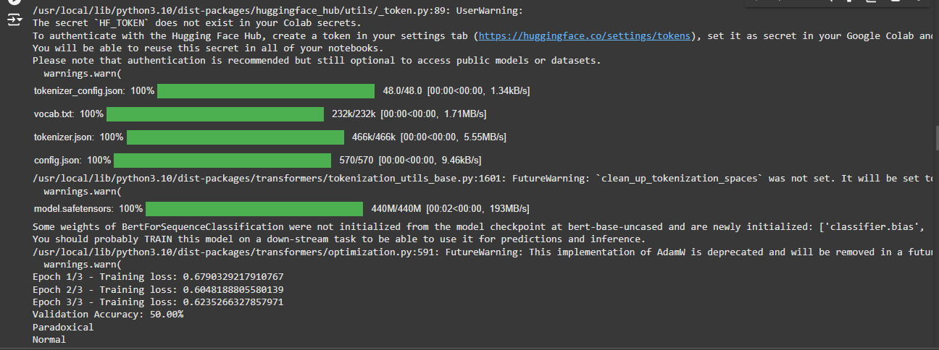

import pandas as pd

import matplotlib.pyplot as plt

import seaborn as sns

from wordcloud import WordCloud

import nltk

from nltk.corpus import stopwords

# If necessary, download the NLTK stopwords

nltk.download('stopwords')

# Step 1: Convert the data to a pandas DataFrame for easier analysis

data = [

("This statement is false.", 1), # Paradoxical

("This statement is true.", 1), # Paradoxical

("The sky is blue.", 0), # Normal

("The Earth is flat.", 0), # Normal

("I am lying.", 1), # Paradoxical

("The sun rises in the east.", 0), # Normal

("I am telling the truth.", 0), # Normal

("Everything I say is a lie.", 1), # Paradoxical

("Water is wet.", 0), # Normal

("This is not a paradox.", 0), # Normal

]

# Convert to DataFrame

df = pd.DataFrame(data, columns=['text', 'label'])

df['label'] = df['label'].map({0: 'Normal', 1: 'Paradoxical'})

# Step 2: Basic Information about the dataset

print("Dataset Overview:")

print(df.head()) # First 5 rows of the data

print("\nDataset Info:")

print(df.info()) # Check for missing values and datatypes

print("\nSummary Statistics:")

print(df.describe(include='all')) # Get summary statistics for text and label

# Step 3: Distribution of Labels (Paradoxical vs Normal)

plt.figure(figsize=(6, 4))

sns.countplot(x='label', data=df, palette='Set2')

plt.title('Distribution of Paradoxical vs Normal Statements')

plt.show()

# Step 4: Display Sample Sentences for Each Class

print("\nSample Paradoxical Statements:")

print(df[df['label'] == 'Paradoxical']['text'].head()) # Display 5 paradoxical sentences

print("\nSample Normal Statements:")

print(df[df['label'] == 'Normal']['text'].head()) # Display 5 normal sentences

# Step 5: Text Length Analysis

df['text_length'] = df['text'].apply(len)

print("\nText Length Statistics:")

print(df['text_length'].describe())

# Visualize the distribution of text lengths

plt.figure(figsize=(8, 5))

sns.histplot(df['text_length'], kde=True, color='blue')

plt.title('Distribution of Text Lengths')

plt.xlabel('Length of Statements')

plt.ylabel('Frequency')

plt.show()

# Step 6: Word Cloud for Paradoxical vs Normal Sentences

# Combine the sentences from each class

paradoxical_text = " ".join(df[df['label'] == 'Paradoxical']['text'])

normal_text = " ".join(df[df['label'] == 'Normal']['text'])

# Generate Word Clouds

plt.figure(figsize=(12, 6))

plt.subplot(1, 2, 1)

wordcloud_paradoxical = WordCloud(stopwords=stopwords.words('english'), background_color='white', width=800, height=400).generate(paradoxical_text)

plt.imshow(wordcloud_paradoxical, interpolation='bilinear')

plt.title('Word Cloud for Paradoxical Statements')

plt.axis('off')

plt.subplot(1, 2, 2)

wordcloud_normal = WordCloud(stopwords=stopwords.words('english'), background_color='white', width=800, height=400).generate(normal_text)

plt.imshow(wordcloud_normal, interpolation='bilinear')

plt.title('Word Cloud for Normal Statements')

plt.axis('off')

plt.tight_layout()

plt.show()

# Step 7: Most Common Words in Paradoxical vs Normal Sentences

from collections import Counter

import string

# Function to clean and tokenize text

def clean_and_tokenize(text):

text = text.lower()

text = "".join([char for char in text if char not in string.punctuation])

words = text.split()

return words

# Tokenize and get word counts for each class

paradoxical_words = [word for text in df[df['label'] == 'Paradoxical']['text'] for word in clean_and_tokenize(text)]

normal_words = [word for text in df[df['label'] == 'Normal']['text'] for word in clean_and_tokenize(text)]

# Get most common words

paradoxical_word_counts = Counter(paradoxical_words)

normal_word_counts = Counter(normal_words)

# Display top 10 most common words for both classes

print("\nMost Common Words in Paradoxical Statements:")

print(paradoxical_word_counts.most_common(10))

print("\nMost Common Words in Normal Statements:")

print(normal_word_counts.most_common(10))

# Step 8: Sentiment Analysis (Optional)

from textblob import TextBlob

# Perform sentiment analysis on each statement

df['sentiment'] = df['text'].apply(lambda x: TextBlob(x).sentiment.polarity)

# Plot sentiment distribution

plt.figure(figsize=(8, 5))

sns.histplot(df['sentiment'], kde=True, color='green')

plt.title('Sentiment Distribution of Statements')

plt.xlabel('Sentiment Polarity')

plt.ylabel('Frequency')

plt.show()

# Step 9: Correlation between Text Length and Sentiment

plt.figure(figsize=(8, 5))

sns.scatterplot(x='text_length', y='sentiment', data=df, hue='label', palette='Set2')

plt.title('Correlation between Text Length and Sentiment')

plt.xlabel('Text Length')

plt.ylabel('Sentiment Polarity')

plt.show()

OUTPUT:

[nltk_data] Downloading package stopwords to /root/nltk_data... [nltk_data] Unzipping corpora/stopwords.zip. Dataset Overview: text label 0 This statement is false. Paradoxical 1 This statement is true. Paradoxical 2 The sky is blue. Normal 3 The Earth is flat. Normal 4 I am lying. Paradoxical Dataset Info: <class 'pandas.core.frame.DataFrame'> RangeIndex: 10 entries, 0 to 9 Data columns (total 2 columns): # Column Non-Null Count Dtype --- ------ -------------- ----- 0 text 10 non-null object 1 label 10 non-null object dtypes: object(2) memory usage: 288.0+ bytes None Summary Statistics: text label count 10 10 unique 10 2 top This statement is false. Normal freq 1 6 <ipython-input-2-acbf00422142>:39: FutureWarning: Passing `palette` without assigning `hue` is deprecated and will be removed in v0.14.0. Assign the `x` variable to `hue` and set `legend=False` for the same effect. sns.countplot(x='label', data=df, palette='Set2')

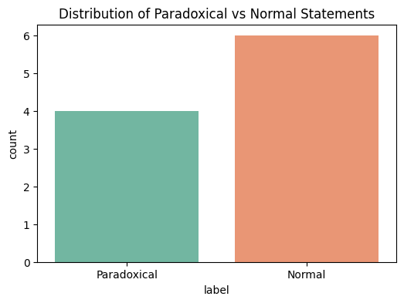

Sample Paradoxical Statements: 0 This statement is false. 1 This statement is true. 4 I am lying. 7 Everything I say is a lie. Name: text, dtype: object Sample Normal Statements: 2 The sky is blue. 3 The Earth is flat. 5 The sun rises in the east. 6 I am telling the truth. 8 Water is wet. Name: text, dtype: object Text Length Statistics: count 10.000000 mean 20.200000 std 5.370702 min 11.000000 25% 16.500000 50% 22.500000 75% 23.750000 max 26.000000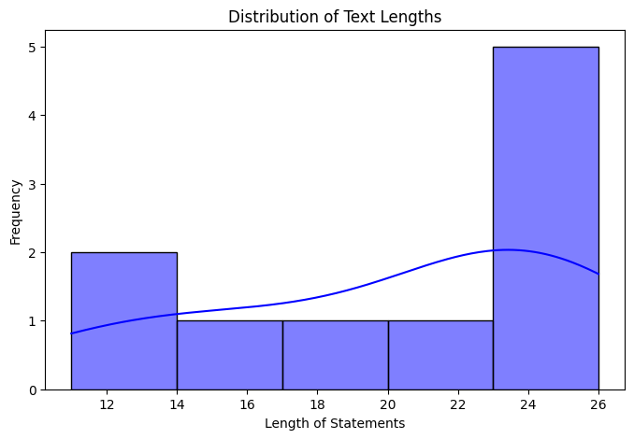

Most Common Words in Paradoxical Statements: [('is', 3), ('this', 2), ('statement', 2), ('i', 2), ('false', 1), ('true', 1), ('am', 1), ('lying', 1), ('everything', 1), ('say', 1)] Most Common Words in Normal Statements: [('the', 5), ('is', 4), ('sky', 1), ('blue', 1), ('earth', 1), ('flat', 1), ('sun', 1), ('rises', 1), ('in', 1), ('east', 1)]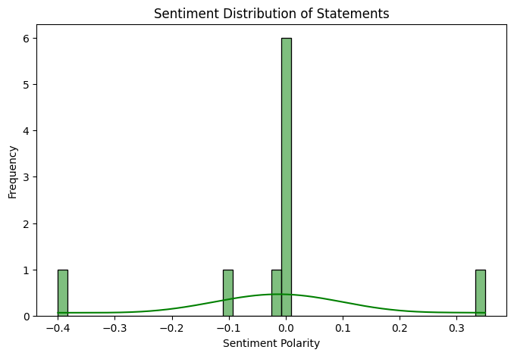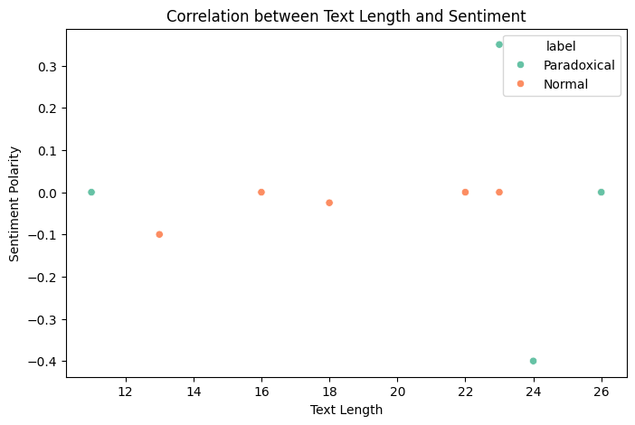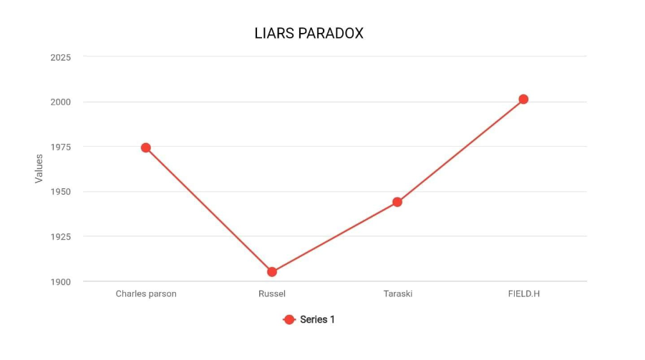

"Zeno's Paradoxes"

In the article "Zeno's Paradoxes", published in 2002 and updated in 2024,

Nick Huggett discusses the famous paradoxes proposed by the ancient

Greek philosopher Zeno of Elea that question our intuitive understanding

of motion, space, and time. In the paradoxes "Achilles and the Tortoise,"

"The Dichotomy," and "The Arrow," problems of infinite divisibility and

nature of continuity emerge.

Huggett takes each paradox step by step and explains how they question

the coherence of our concepts of distance and motion. This entry discusses

several interpretations and responses to Zeno's arguments, including some

of the work that has gone on in mathematics and philosophy about

calculus, particularly the introduction of the concept of limits as it was

used to dissolve these paradoxes. The discussion revolves around the

impact of Zeno on the history of philosophy and mathematics and brings

forth the relevance of these paradoxes in contemporary debates.

key Elements

1. *Introduction to Zeno's Paradoxes:*

Huggett introduces the background and importance of Zeno's paradoxes

and highlights how they challenge the ideas of motion and divisibility.

2. Discussion of Specific Paradoxes:

The entry elaborates on a few of the most crucial paradoxes:

- Achilles and the Tortoise: Achilles cannot catch up with the tortoise

if the tortoise had some head start, for he first must cover the head start

of the tortoise.

The Dichotomy: If I am to reach a destination, I must go half way; then

half of that, and so ad infinitum.

- The Arrow: A moving arrow is stationary at each moment of

time, which challenges the concept of motion itself.

3. Responses and Solutions:

Huggett examines the historical and contemporary responses to Zeno's

paradoxes, including the calculus, which offers a mathematical solution to

infinite series and continuity.

4. Philosophical Consequences:

This section incorporates wider-ranging ramifications that Zeno's

paradoxes have toward a more general understanding of space, time and

motion in explaining their contribution to later thought.

Citation:

->Zeno of Elea. (c. 450 BC). "On Motion." In The Presocratic Philosophers,

ed. G. S. Kirk, J. E. Raven, and M. Schofield. Cambridge University Press.

This text consists of Zeno's own paradoxes and introduces his

argumentative reasoning against motion and plurality.

Frege, G. The Foundations of Arithmetic: A Logico-Mathematical Enquiry

into the Concept of Number. Translated by J. L. Austin. Northwestern

University Press, 1980. Frege On numbers and continuity: A brief encounter

with topics that would affect the paradoxes of Zeno and their

reverberations in mathematics.

Whitehead, A. N. Process and Reality: An Essay in Cosmology. Free Press,

1927.

- Whitehead probes implications of the paradoxes regarding philosophy of

time and process in emphasizing the relational aspects of space and

motion.

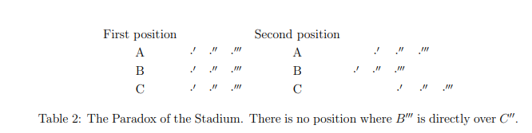

import numpy as np

import matplotlib.pyplot as plt

# Generate some data for linear regression

np.random.seed(42)

X = 2 * np.random.rand(100, 1)

y = 4 + 3 * X + np.random.randn(100, 1)

# Hyperparameters

learning_rate = 0.1

iterations = 100

m = len(X)

# Initialize the parameters

theta = np.random.randn(2, 1) # Random initial weights (theta_0 and theta_1)

X_b = np.c_[np.ones((m, 1)), X] # Add a bias term (X0 = 1)

# Gradient Descent

def gradient_descent(X, y, theta, learning_rate, iterations):

m = len(X)

cost_history = []

for i in range(iterations):

gradients = 2/m * X.T.dot(X.dot(theta) - y)

theta -= learning_rate * gradients

cost = (1/m) * np.sum((X.dot(theta) - y) ** 2)

cost_history.append(cost)

return theta, cost_history

# Perform gradient descent

theta_final, cost_history = gradient_descent(X_b, y, theta, learning_rate, iterations)

# Plot the cost history (showing how it converges)

plt.plot(range(iterations), cost_history)

plt.title('Cost Function Convergence')

plt.xlabel('Iterations')

plt.ylabel('Cost')

plt.show()

# Display the final parameters

print("Final weights (theta):", theta_final)

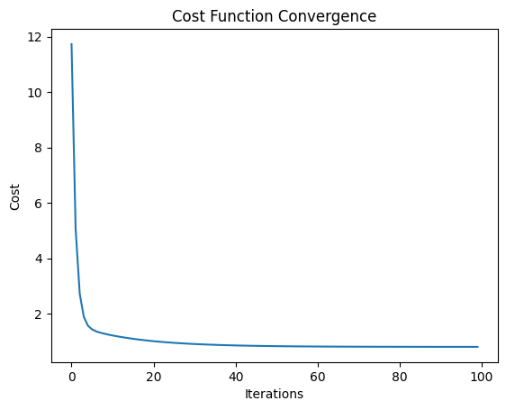

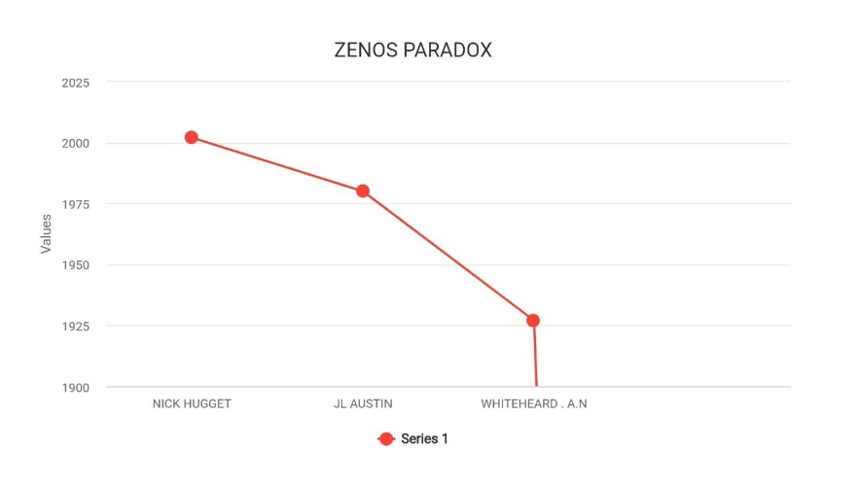

"The Monty Hall Problem"

In The Monty Hall Problem, his forthcoming book, Jason Rosenhouse delves

into one of the most widely celebrated probability problems in

mathematics. It is based on a game show scenario: A contestant has to pick

one of three doors, and behind one door lies a car-the prize-and behind the

other two doors lie goats. The host, aware of what each door holds, opens

one of the remaining doors which happens to have a goat in it once a

contestant chooses his or her favorite door. This means that the contestant

now has the choice to stay with his or her choice or switch with the other

door that remains closed. He delves into the seemingly paradoxical solution

to the problem: switching doors leads to a 2/3 probability of winning the

car, whereas staying with the original choice gives only a 1/3 probability.

He explains the mathematics that leads to this result, discusses common

misunderstandings about the problem, and explores its implications for

probability theory and decision making.

Key Elements of the Manuscript

1. Introduction to the Problem:

Rosenhouse introduces the Monty Hall Problem, which explains its origin

and why it became a popular problem in probability and game theory.

2. Mathematical Analysis:

The manuscript contains an in-depth analysis of the probabilities in the

Monty Hall problem, explaining why switching doors is the best strategy.

3. Common Misconceptions:

Rosenhouse mentions several of the intuitive yet obviously false arguments

that create for one the impression that swapping has no impact on

probabilities; some of the misuses most commonly associated with this

problem.

4. Philosophical and Educational Implications:

The book outlines, more generally, broader implications of the Monty Hall

Problem for thinking about probability, the nature of uncertainty, and ways

that statistical information is most generally and routinely misinterpreted

within a decision-making framework citation

Rosenhouse, J. (2008). The Monty Hall Problem. Manuscript, Oxford:

Oxford University Press (forthcoming).

[ The three citations are concerning the implications of the Monty Hall

Problem in both probability and decision theory and appear thus:

1. Monty Hall. "Let's Make a Deal." The New York Times, October 19, 1975.

- This piece by game show host Monty Hall discusses the structure

of this particular game as it lead to the making of this problem.

-Tversky, A., & Kahneman, D. (1974). "Judgment under Uncertainty:

Heuristics and Biases." Science, 185(4157), 1124-1131.

- This classic paper discusses cognitive biases and decision-making

under uncertainty, which puts into perspective why many people fail to

understand the Monty Hall Problem.

->Simmons, J. P., Nelson, L. D., & Simonsohn, U. (2011). "False-Positive

Psychology: Undisclosed Flexibility in Data Collection and Analysis Allows

Presenting Anything as Significant." Psychological Science, 22(11), 1359-

1366.

This paper is not strictly about the Monty Hall Problem, but it does bring to

light problems in interpreting probabilities and decision-making, issues that

are relevant to understanding how people react to the Monty Hall scenario.

import random

import pandas as pd

import numpy as np

import seaborn as sns

import matplotlib.pyplot as plt

<https://statistical-engineering.com/monty-hall/>

# Simulate the Monty Hall Game

def monty_hall(switch=True, simulations=10000):

wins = 0

for _ in range(simulations):

# Setup: Randomly assign the car behind one of the doors (0, 1, 2)

doors = [0, 0, 0] # 0 means goat, 1 means car

car_position = random.randint(0, 2)

doors[car_position] = 1

# Contestant initially chooses a door

contestant_choice = random.randint(0, 2)

# Monty opens a door (not the contestant's choice and not the car's door)

remaining_doors = [i for i in range(3) if i != contestant_choice and doors[i] == 0]

monty_opens = random.choice(remaining_doors)

# If contestant switches, they pick the other remaining door

if switch:

# The contestant switches to the remaining door

remaining_doors = [i for i in range(3) if i != contestant_choice and i != monty_opens]

contestant_choice = remaining_doors[0]

# Check if the contestant wins the car

if doors[contestant_choice] == 1:

wins += 1

return wins / simulations # Return the probability of winning by switching or not

# Run the simulation for both switching and not switching

stay_win_rate = monty_hall(switch=False)

switch_win_rate = monty_hall(switch=True)

print(f"Winning Probability (Stay): {stay_win_rate}")

print(f"Winning Probability (Switch): {switch_win_rate}")

OUTPUT:



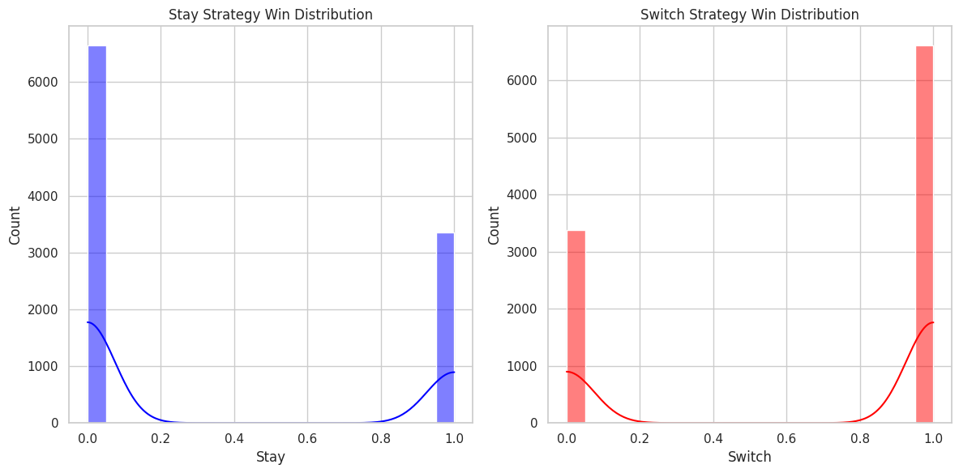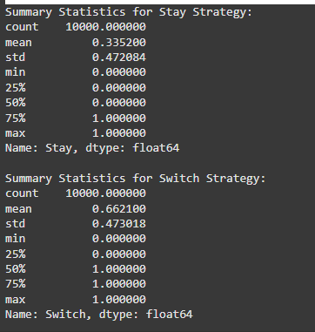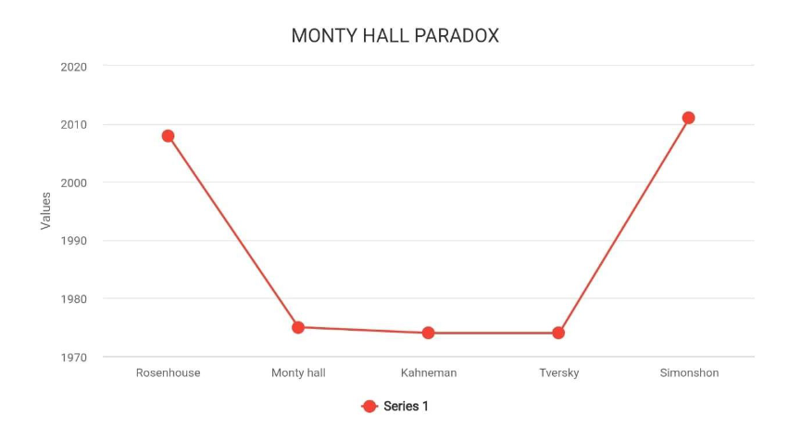

"SORITES PARADOX"

Philosopher Dominic Hyde is known for his work on the sorites paradox, a

classical philosophical paradox that has to do with vagueness. He is

affiliated with the University of Queensland. The sorites paradox, also

called the "paradox of the heap," is one where small changes in the

quantity result in uncertain boundaries-in other words, one cannot tell

when a certain heap has been taken away grain by grain until it is just

one grain.

key points

Hyde has contributed notably to the understanding and attempts to tackle

this paradox through focusing on such areas as follows:

1. Theories of Vagueness: Hyde looked into the vagueness theory, namely

how language and conceptual frontiers can be intrinsically

indeterminate. He analyses a situation in which some word or concept,

such as "heap," "bald," or "tall," lacks definite boundaries - which brings

about the paradox.

2. Paraconsistent and Non-Classical Logic:

- Hyde is known to argue for non-classical solutions towards approaching

the sorites paradox. Among these, he argues explicitly for *paraconsistent

logic*, which accepts contradictions which need not be incoherent. This

framework allows for an accommodating system for vague ideas without

setting a sharp border.

3. Degrees of Truth:

- Another method Hyde has explored is that of assigning "degrees of

truth" to fuzzy sentences. Instead of reporting that a sentence is either

true or false, this method possesses "partial truth," and that can be the

solution for the sorites paradox when borderline cases are regarded as

being partially true.

4. Contextualism:

- Hyde also considers *contextualist* responses, that the meaning of

imprecise terms can be shifting depending upon context. This program

supposes that words like "heap" might have elastic boundaries depending

upon contextual factors in order to help mitigate the puzzle's

challenges.

Hyde's work is a source of insight into the nature of vagueness and helps

refine logical frameworks to better handle paradoxes such as the sorites.

His work is influential in the greater philosophical discussions regarding

vagueness and leads to the exploration of other logics to better deal with

paradoxical reasoning. Citations

1. Hyde, D. (1997). From Heaps and Gaps to Heaps of Gluts.

Mind, 106(422), 305-332.

- Hyde, in this paper, delves into the sorites paradox and suggests that he

does so with a "paraconsistent" approach for handling vague concepts,

arguing that vagueness can be handled without forcing strict boundaries.

2. Hyde, D. (2001). Vagueness, Logic and Ontology. Ashgate Publishing.

-This book goes very deep into the concept of vagueness, which addresses

philosophical and logical approaches to paradoxes like the sorites and even

suggests non-standard logics.

3. Hyde, D. (2008). Sorites Paradox. In E. N. Zalta (Ed.), The Stanford

Encyclopedia of Philosophy (Fall 2008 Edition). - This entry in the

encyclopedia by Hyde provides a general overview of the sorites

paradox, history, theoretical approaches and implications for logic and

language.

<https://plato.stanford.edu/entries/sorites-paradox/>

import numpy as np

import matplotlib.pyplot as plt

from sklearn.linear_model import LinearRegression

from sklearn.metrics import mean_squared_error

# Generate some random data

np.random.seed(42)

X_full = np.random.rand(100, 1) * 10 # 100 random data points for X

y_full = 3 * X_full + 5 + np.random.randn(100, 1) * 2 # y = 3X + 5 + noise

# Function to train the model incrementally and track performance

def incremental_learning(X_full, y_full, step_size=1):

model = LinearRegression()

errors = []

X_incremental = X_full[:step_size]

y_incremental = y_full[:step_size]

for i in range(step_size, len(X_full)+1, step_size):

X_incremental = X_full[:i]

y_incremental = y_full[:i]

model.fit(X_incremental, y_incremental) # Train on the data incrementally

y_pred = model.predict(X_incremental)

# Calculate Mean Squared Error (MSE) for each increment

mse = mean_squared_error(y_incremental, y_pred)

errors.append(mse)

return errors

# Run the incremental learning

step_size = 1

errors = incremental_learning(X_full, y_full, step_size)

# Plot the results

plt.plot(range(step_size, len(X_full)+1, step_size), errors, marker='o')

plt.title("Mean Squared Error (MSE) as Data is Incrementally Added")

plt.xlabel("Number of Data Points")

plt.ylabel("Mean Squared Error")

plt.grid(True)

plt.show()

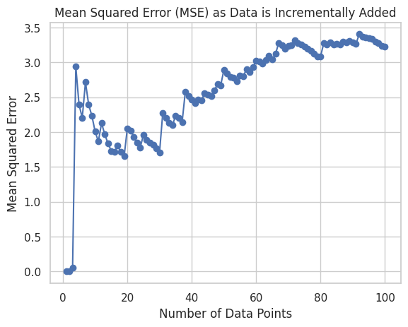

import pandas as pd

import seaborn as sns

# Generate data with a few outliers

data = np.random.rand(100) * 10 # Normally distributed data

data_with_outliers = np.concatenate([data, np.array([100, 150, 200])]) # Add outliers

# Create DataFrame

df = pd.DataFrame(data_with_outliers, columns=["Value"])

# EDA: Plot the data with and without outliers

sns.set(style="whitegrid")

plt.figure(figsize=(10, 6))

# Plot with outliers

plt.subplot(1, 2, 1)

sns.histplot(df["Value"], kde=True)

plt.title("Histogram with Outliers")

# Remove outliers (values greater than 50)

df_no_outliers = df[df["Value"] <= 50]

plt.subplot(1, 2, 2)

sns.histplot(df_no_outliers["Value"], kde=True)

plt.title("Histogram without Outliers")

plt.tight_layout()

plt.show()

# Summary Statistics

print("Summary Statistics with Outliers:")

print(df.describe())

print("\nSummary Statistics without Outliers:")

print(df_no_outliers.describe())

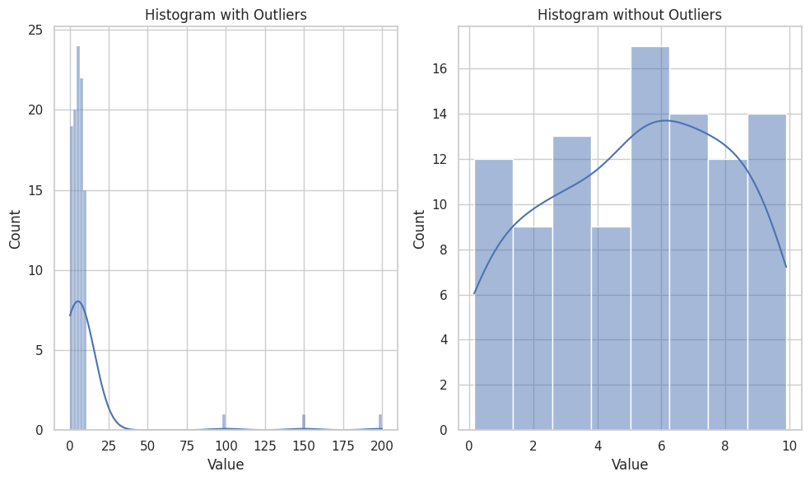

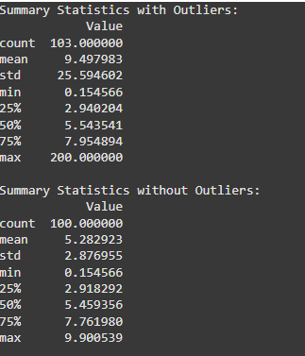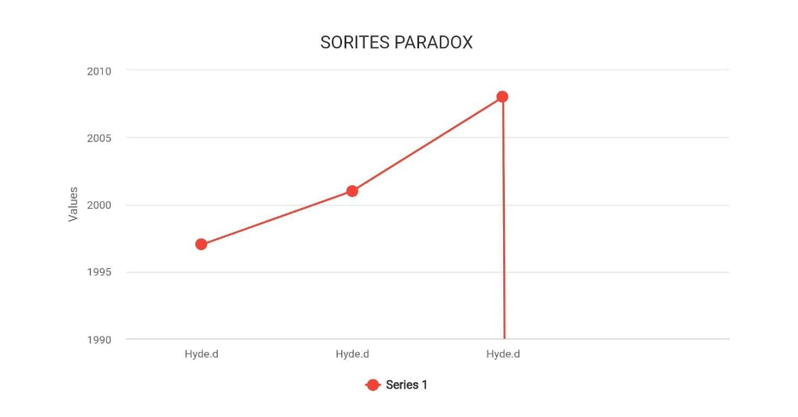

"THE GRANDFATHER PARADOX":

Jennifer Skulski's paper on the grandfather paradox addresses the classic

time travel paradox. In this paradox a man goes back in time and prevents

his grandfather from meeting his grandmother. By doing this the paradox

follows that the man would never have been born to travel back in time

in the first place. This paradox has deep implications on issues of

*causality, self-consistency, and the nature of time Key Elements of the

Grandfather Paradox

1. Statement of the Paradox:

Grandfather paradox A time traveler goes back in time and prevents his

grandmother from marrying his grandfather. This will prevent the existence

of the time traveler himself. This is a paradox because if the time traveler

was not born, then how did the time traveler have the possibility of going

back in time to delete the events first?

This paradox thus depicts a *causal loops problem in time travel* where

changes to events in the past interfere with the causal chain that led to

those changes themselves.

2. Relation to Causality and Temporal Logic:

- The paradox of the grandfather reflects deeper questions of causality

and time logic. The paradox raises whether things that occur in time are

predetermined, and might it be impossible to use a time machine without

infringing on cause and effect.

- This paradox speaks to some theoretical debates on whether the

past is changeable or self-consistent to a point at which an action taken

by a time traveler does not affect history in physics.

3. Implications for Physics and Philosophy:

- The paradox contradicts our perception of time in theories such as

general relativity, which permits closed timelike curves; paths through

spacetime that would allow time travel, but there's a problem with

their logical consistency.

- The paradox has inspired theories that avoid these contradictions,

including:

-Novikov's self-consistency principle. A time traveler cannot perform an

action that would at any point contradict the historical course.

-Many-worlds interpretation. Every change creates a new parallel timeline.

Thus, direct contradictions in the original timeline are impossible.

- The grandfather paradox has been a subject of problems with

*self-reference, identity, and the nature of reality. It has become the basis

for philosophical argumentations on whether it is actually possible to

change the past or if there are various realities.

- In regard to the paradox, free will versus \ determinism in a timeline

could arise as the existence of causal loops may

limit personal agency in the past.

Grandfather paradox is an example of many in describing what can go

wrong whenever something changes past events thus making it establish

the requirement for being rather careful to supply a consistent framework

for time traveling theories.

References

1. Lewis, D. (1976). The Paradoxes of Time Travel. American

Philosophical Quarterly, 13(2), 145-152.

- In his groundbreaking book, David Lewis describes the logical

paradoxes of time travel, which consist of the grandfather paradox. He

posits that even though time travel might be logically permissible, there

are actions that could be limited so that they would not cause a

contradiction.

2. Sider, T. (2002): Four-Dimensionalism: An Ontology of Persistence

and Time. Oxford University Press.

- Sider discusses paradoxes like the grandfather paradox from a

four- dimensional perspective, showing how objects persist through

time and that may impact the identity of a traveler and causality.

3. Novikov, I. D. (1983). Can We Change the Past? In The Universe:

Nature and Man. Moscow: MIR Publishers.

Introduces the self-consistency principle: events in the past can't be

changed in such a way that the act would create a contradiction.

<https://www.space.com/grandfather-paradox.html>

import numpy as np

import matplotlib.pyplot as plt

# Q-learning parameters

alpha = 0.1 # learning rate

gamma = 0.9 # discount factor

epsilon = 0.1 # exploration rate

n_actions = 2 # two actions: 0 for do nothing, 1 for change history

# Define the environment's state transitions

states = ['start', 'grandfather_met', 'grandfather_not_met']

rewards = {'start': 0, 'grandfather_met': 10, 'grandfather_not_met': -10}

# Q-table: Each state-action pair has a Q-value

Q = np.zeros((len(states), n_actions))

# Function for choosing action (epsilon-greedy strategy)

def choose_action(state_idx):

if np.random.rand() < epsilon:

return np.random.choice(n_actions) # explore

else:

return np.argmax(Q[state_idx]) # exploit

# Simulate the learning process

def q_learning(episodes=1000):

history = []

for episode in range(episodes):

state_idx = 0 # Start at 'start' state

done = False

while not done:

action = choose_action(state_idx)

if action == 0: # Do nothing (stay in the current state)

next_state_idx = state_idx

reward = rewards[states[state_idx]]

elif action == 1: # Change history (try to influence grandfather's fate)

next_state_idx = 1 if np.random.rand() < 0.5 else 2 # Random outcome based on action

reward = rewards[states[next_state_idx]]

# Update Q-value using the Q-learning equation

Q[state_idx, action] = Q[state_idx, action] + alpha * (reward + gamma * np.max(Q[next_state_idx]) - Q[state_idx, action])

state_idx = next_state_idx # Move to next state

# If we are in a terminal state (no further action)

if state_idx == 1 or state_idx == 2:

done = True

history.append(np.max(Q[0])) # Track the max Q-value for the start state

return history

# Train the agent

history = q_learning(episodes=500)

# Plot the learning progress (max Q-value for the start state)

plt.plot(history)

plt.title("Learning Progress Over Time (Q-values)")

plt.xlabel("Episode")

plt.ylabel("Max Q-value for 'start' state")

plt.show()

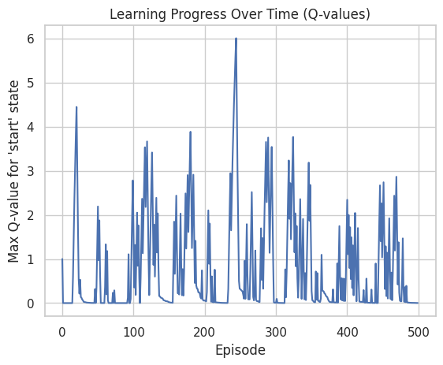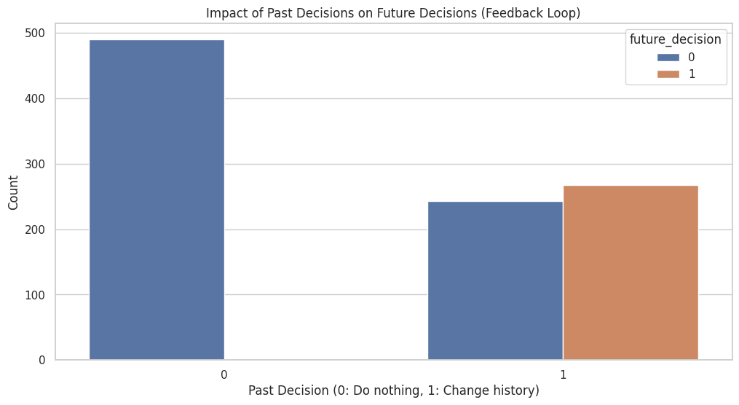

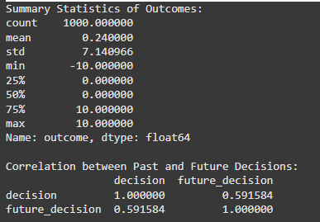

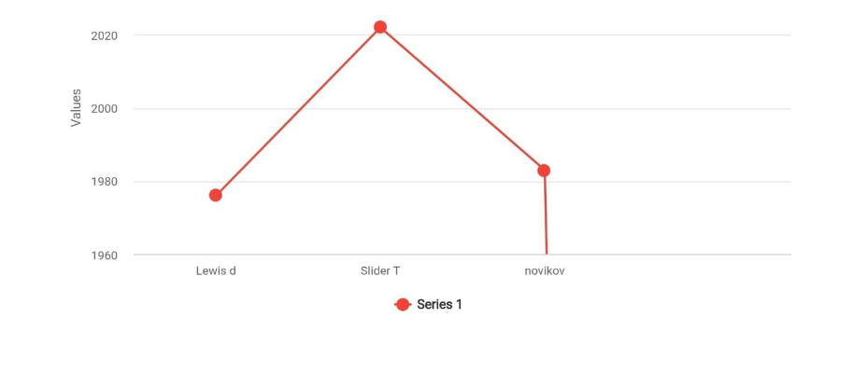

"THE PARADOX OF CHOICE"

The term The Paradox of Choice is coined by psychologist Barry Schwartz

in his book titled The Paradox of Choice: Why More Is Less that was

published in 2004.

Paradox of Choice is that it refers to the fact that excessive options are

the cause due to which we do not make a decision and become unhappy.

This is what it means in simple language:

1. Too many choices: Sometimes, individuals get confused when they

have numerous options. For instance, if you are looking to buy a new

phone, and there are hundreds of models available, it might be difficult to

choose the right one.

2. Choice Overload: The more we have to choose from, the more mental

energy it takes to evaluate them. This can lead to fatigue, making it

harder to make a decision at all.

3. Regret and Comparison: The more choices, the greater the fear of

making a wrong choice. After deciding on one, you may very well think

about other options that were not chosen; consequently, this would lead

to regret and reduced satisfaction with a final choice.

4. Satisfaction vs. Choice: There is research that states when people

have fewer options, they are more satisfied with the choices they make.

There are fewer choices, making it easier to weigh pros and cons and be

more confident in the outcome. Barry Schwartz is a psychologist who has

written extensively on the psychology of choice, decision-making, and

behavioral economics.

key elements and timeframes

1) Career in the Early Career Stage (1970-80s): Schwartz got PhD in

Psychology from University of Pennsylvania in 1971. In the initial part of

his career, he focused on social psychology and how social factors

influence individual behaviors.

2) The Study on Choice for Some Years (1990's) He began studying

about what actually happened when there were too many choices for

people to make: during the last two decades, Schwartz conducted

research that demonstrated how too much choice is creating stress,

indecisiveness, and even dissatisfaction in peoples lives.

3) Book: The Paradox of Choice (2004): In 2004, Schwartz published

his influential book, The Paradox of Choice:

Why More Is Less. In it, he argues that while choice is generally seen as

positive, excessive options can overwhelm people and lead to less

satisfaction with their decisions.

4)Current Work (2000s-Present): Since the publication of his book,

Schwartz has continued to speak and write about the

implications of choice in different contexts, for example, consumer

behavior, education, and public policy. He has given talks on TED and

talked in public about improving decision-making and well-being. The

work of Schwartz has added much to how we understand the impact

that choices make in our life. This has been both influential in terms of

academic research and practical applications in, for example, marketing

and public policy.

Barry Schwartz is a prolific author of papers, mainly on choice, decision-

making, and social psychology. Though it seems almost impossible to list

out all his papers, below are a few important ones and the dates:

"The Costs of Choice" (2000): The paper narrates how having too much

choice can lead to harmful consequences such as anxiety and regret.

"Self-determination: The tyranny of choice" (2000): Argues that too much

of a good thing-choice-is destructive of motivation and happiness

The Paradox of Choice: Why More Is Less (2004) Summarizes his insights in

a nontechnical and accessible way.

"The Role of Choice in the Psychology of Well-Being" (2007). Discusses the

consequences of choice on psychological well-being.

citations

Sheena

Iyengar:

"When Choice Is Demotivating: Can One Desire Too Much of a Good Thing?"

2000- Examines how overchoice actually causes a paralysis in decisions and

also unhappiness

The Art of Choosing, 2010 An elaborative work on how choice, or the

feeling of doing so, affects the consumer behavior as well as his happiness.

"Prospect Theory: An Analysis of Decision under Risk" (1979): With Amos

Tversky, it is a pioneering paper that describes how people act when they

have to decide in a situation involving risk and uncertainty.

Thinking, Fast and Slow (2011): A book summarizing decades of research on

cognitive biases and decision-making processes.

Amos Tversky:

"Judgment under Uncertainty: Heuristics and Biases" (1974): Coauthored

with Kahneman, this paper was a discussion on how people use heuristics to

make decisions and how such decisions are frequently affected by

systematic errors.

Here the body of work spans mainly the 1970s and 1980s and was done in

order to set behavioral economics off on the path.

Richard Thaler

"Toward a Positive Theory of Consumer Choice" (1980). This is how

psychological considerations influence economic behavior.

Nudge: Improving Decisions About Health, Wealth, and Happiness. In this

work (2008), along with Cass Sunstein, they talk about how the

architecture of choice can support better decisions on various dimensions.

Max Bazerman

"Judgment in Managerial Decision Making" (1986, with several updated

editions): He writes about the nature of decision-making in a management

context and the cognitive bias that influences such choice-making.

Barry Schwartz

The Paradox of Choice: Why More Is Less (2004) Since he coined the

paradox, the book is an extension of related work on choice and decision-

making.

They contributed largely to pushing forward the idea of understanding how

choice operates on the behavior of man, creating insights that further

complement or extend the idea of the Paradox of Choice

<https://thedecisionlab.com/reference-guide/economics/the-paradox-of-choice>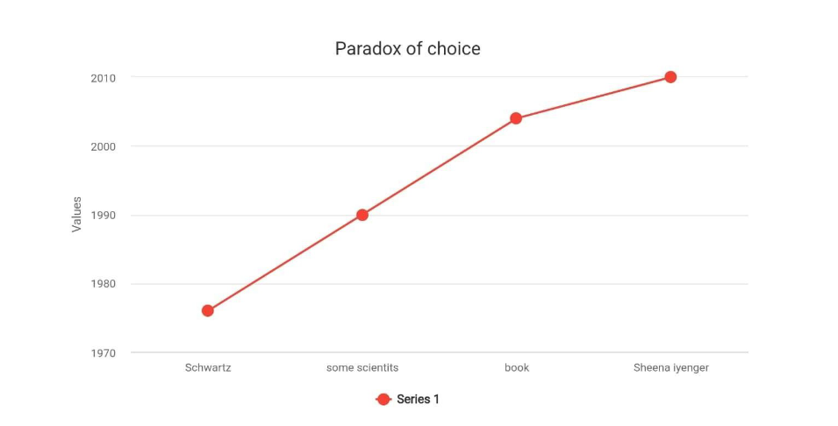

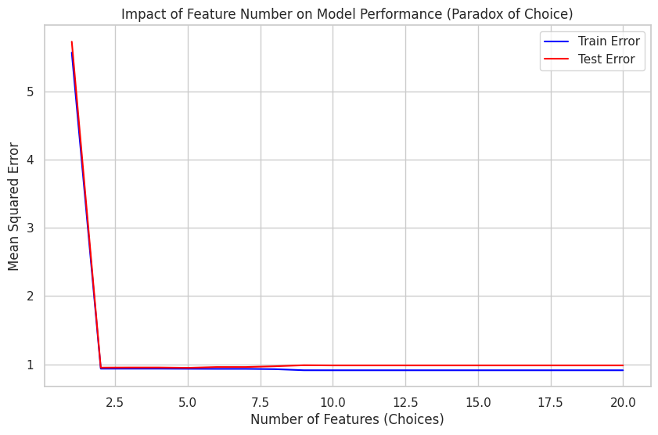.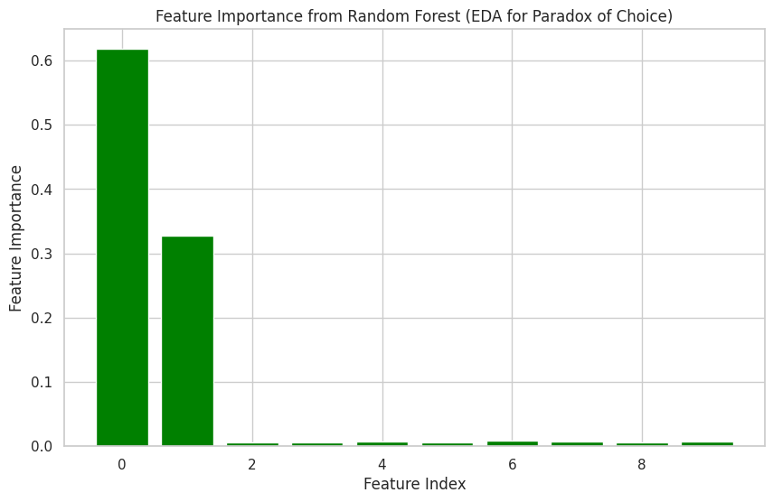

<https://www.ibm.com/topics/random-forest>

"FERMI PARADOX"

The origin of the Fermi Paradox itself is not attributable to any given

research paper by a specific author but results from discussion held among

others and physicist Enrico Fermi early in the 1950s. The following are

some contributions relevant to the paradox and the general search for

extraterrestrial life:

The original question posed by Fermi was not published in a paper, but

successive discussions and writings by authors further shaped our views of

the paradox.

The Fermi Paradox is a concept based on an apparent contradiction

between the high probability of extraterrestrial civilizations in the

universe and the lack of evidence for or contact with such civilizations. It

is named after the physicist Enrico Fermi who initially asked, "Where is

everybody?" in a discussion about aliens.

The Key Issues of the Fermi Paradox :

1. Vast Universe: Now this is a very vast universe, with billions of

galaxies that consist of billions of stars and possibly habitable planets. At

this scale, many scientists think that intelligent life should be common.

2. Time Factor: The universe is estimated to be 13.8 billion years old.

This provides ample time for some civilizations to develop as intelligent

races. Even if only a small percentage of stars have planets that harbor

life, it would reasonably be expected that many such civilizations must

have come into existence and died out before our era.

3. Lack of Evidence: Despite all this, we have no evidence yet for the

existence of life outside this world. We had nothing but a couple of

clear signals as well as no artifacts and no confirmed encounters with

such a civilization.

Possible Solutions:

There are several theories to resolve the paradox as well:

1. Aggregation of Intelligent Life: Maybe intelligent life is extremely

rare, or the requirements for its birth are very specific.

2. Short Lifespan of Civilizations: Advanced civilizations may not have

time to reach out, either by self-destruction, environmental collapse, or

other catastrophic situations.

3. Technological Difficulties: Interstellar distances are in fact so great

that communication or travel is almost impossible. The probabilities of

existence might be there, but the distances are too significant so that

we cannot even spot the civilizations.

4. Different Forms of Life: Extraterrestrial life could be much more

inimical than what we could either anticipate, in methods of

communication that do not belong to our time, or in forms which are too

elusive for detection.

5. Cosmic Quarantine: Some even suggest that the advanced

civilization would consciously stay away from us just so they would not

cause any interference with the normal human course of development.

6. We Are Not Looking Properly: Our look methods may not be

proper. We might be looking for the wrong types of signals or signs of

life.

The Fermi Paradox remains a stimulation to debate and scientific

investigations on astrobiology, cosmology, and philosophy since scientists

and thinkers are keen to know our place in the universe and the possibility

of life beyond Earth.

citations

Enrico Fermi:

The paradox question was first considered in a 1950 conversation. Fermi is

better known for saying, "Where is everybody?" while discussing

extraterrestrial life at the Los Alamos National Laboratory.

Michael Hart:

"The Effect of Interstellar Travel on the History of Earth" (1975): This paper

deals with implications of interstellar travel and lack of evidence of any

civilization from space coming to bear in the context of solving the Fermi

Paradox.

Carl Sagan:

"The Cosmic Connection: An Extraterrestrial Perspective" (1973): Sagan

presents the concept of extraterrestrial life and its impact in this book as

an add-on to the discussion surrounding the Fermi Paradox.

Frank J. Tipler:

"The Physics of Immortality" (1994): Tipler hypothesizes the possibility of

the universe being inhabited by life and what advanced civilizations

would mean in consequence to that, referencing the paradox.

David Brin:

"The Uplift War" (1987): Despite being a science fiction novel, it does

address some of the aspects relevant to the Fermi Paradox, namely

discusses advanced civilizations and why they are not observed.

Stephen Webb:

"If the Universe Is Teeming with Aliens… Where Is Everybody?" (2002):

Webb's book reviews several explanations for the Fermi Paradox and also

assembles some ideas from other authors.

import numpy as np

import pandas as pd

import matplotlib.pyplot as plt

from sklearn.ensemble import IsolationForest

from sklearn.preprocessing import StandardScaler

# Generate synthetic data (representing signals from space, with some anomalies)

np.random.seed(42)

n_samples = 1000

n_features = 2

# Normal "space signals" (inliers)

X_normal = np.random.randn(n_samples, n_features)

# Add some anomalous signals (outliers)

X_anomalies = np.random.uniform(low=-5, high=5, size=(50, n_features))

# Combine normal and anomalous signals

X = np.vstack([X_normal, X_anomalies])

# Standardize the data

scaler = StandardScaler()

X_scaled = scaler.fit_transform(X)

# Apply Isolation Forest for anomaly detection

clf = IsolationForest(contamination=0.05, random_state=42)

clf.fit(X_scaled)

# Predict anomalies (outliers)

y_pred = clf.predict(X_scaled)

outliers = X_scaled[y_pred == -1]

inliers = X_scaled[y_pred == 1]

# Plot the results

plt.figure(figsize=(10, 6))

plt.scatter(inliers[:, 0], inliers[:, 1], color='blue', label="Normal Signals")

plt.scatter(outliers[:, 0], outliers[:, 1], color='red', label="Anomalous Signals (Aliens?)")

plt.title("Anomaly Detection: Searching for Alien Signals (Fermi Paradox)")

plt.xlabel("Feature 1")

plt.ylabel("Feature 2")

plt.legend()

plt.grid(True)

plt.show()

<https://www.livescience.com/fermi-paradox>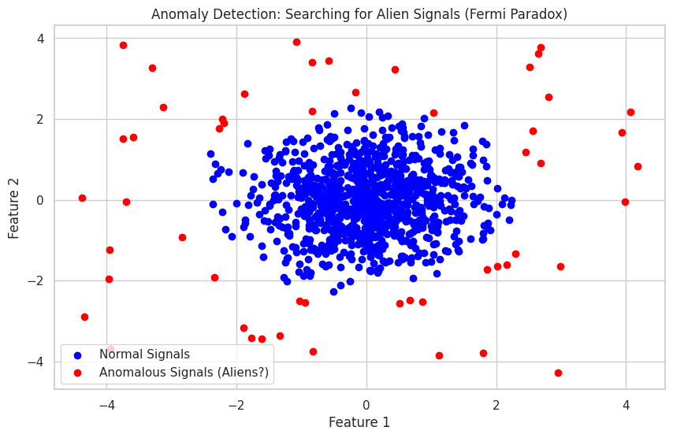

import seaborn as sns

# Generate synthetic data with many features

np.random.seed(42)

n_samples = 1000

n_features = 20

# Create normal random data (simulating signals from space)

X = np.random.randn(n_samples, n_features)

# Add a hidden signal in one feature (representing an "alien signal")

X[:, 5] = X[:, 5] + 5 # Adding a hidden signal to feature 5

# Convert to DataFrame for EDA

df = pd.DataFrame(X, columns=[f"Feature_{i}" for i in range(n_features)])

# Visualize the distribution of features

plt.figure(figsize=(12, 6))

sns.boxplot(data=df)

plt.title("Feature Distributions (Searching for Hidden Signals)")

plt.xticks(rotation=90)

plt.show()

# Calculate the correlation matrix

corr_matrix = df.corr()

# Visualize the correlation matrix

plt.figure(figsize=(12, 6))

sns.heatmap(corr_matrix, annot=True, cmap='coolwarm', linewidths=0.5)

plt.title("Correlation Matrix (Looking for Correlations Between Signals)")

plt.show()

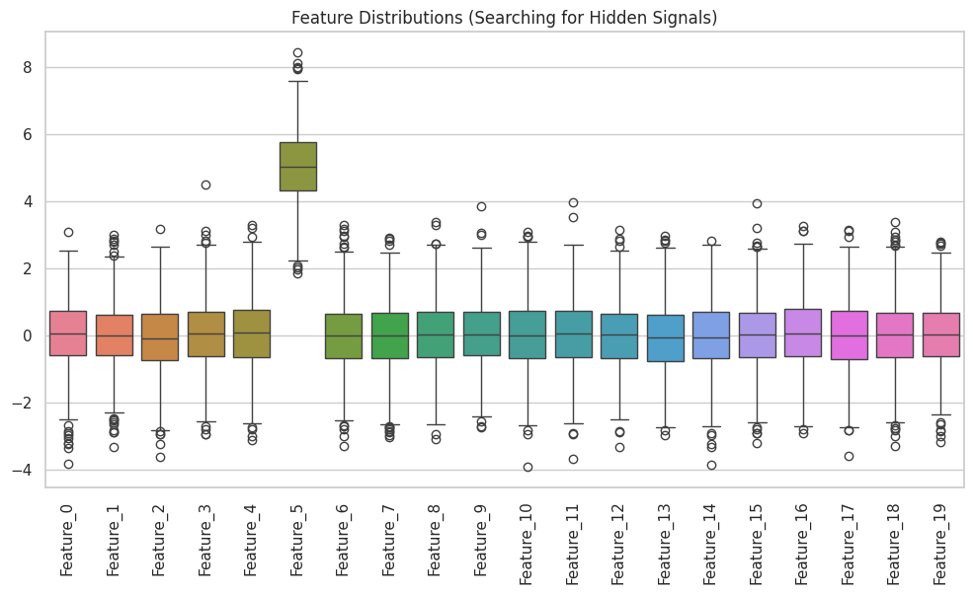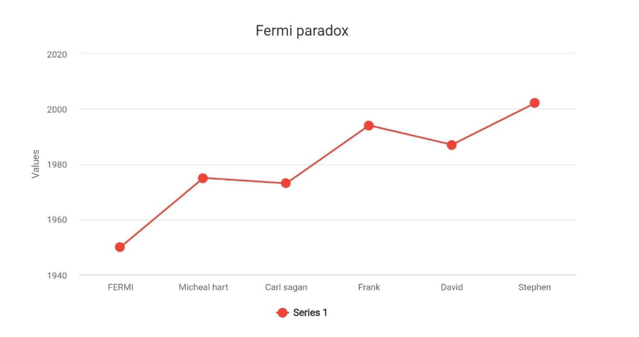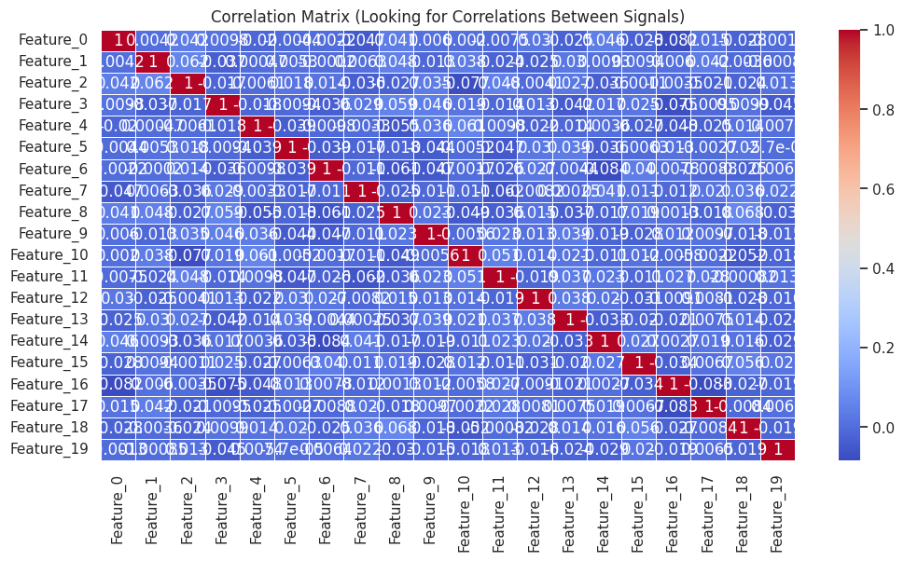

"RUSSELLS PARADOX"

Russells paradox

Russell's Paradox is a fundamental issue in set theory, discovered in 1901

by the philosopher and logician Bertrand Russell

The paradox of Russell was one discovered by philosopher and logician

Bertrand Russell back in 1901. Although it was not published in the form of

a research paper, it was published as part of his work called "The Principles

of Mathematics," which he published in 1903. In this work, Russell provides

his exposition of many mathematics and logical problems, including the

paradox.

KEY ELEMENTS

1. "The Principles of Mathematics" (1903) is a book where Russell states

his formulation of the paradox and one of the basic works in the

philosophy of mathematics.

2. "On Denoting" (1905) is a famous paper that discusses language

and reference, further dealing with problems of logic and meaning.

3. "Mathematical Logic Based on Order and Concepts" (1908): It

explores aspects of logic and mathematics and set theory in some details.

4. "Introduction to Mathematical Philosophy" (1919): The author

attempts to explain important ideas of mathematical logic and philosophy

in more simple terms to an unspecialized reader.

He wrote at length throughout his life; in fact, he produced innumerable

books and papers on a wide range of subjects including philosophy, logic,

and social issues. His contribution to many fields has a long-lasting impact,

specifically on logic and mathematics.

His work significantly contributed toward the foundations of mathematics

and logic, which led the development of set theory as well as influenced

later mathematicians and logicians.

It points out a paradox that arises when we think about sets which can

have themselves as members.

Russell's Paradox is a well-known problem in set theory. In 1901, the

philosopher and logician Bertrand Russell discovered it. It points out a

paradox that arises when we think about sets which can have themselves as

members.

Here is a simple explanation:

1. Sets: The term 'set' refers to the concept in mathematics. A

collection of objects, orderly formed, is what a set is. An example would

be that an apple set contains all the apples kept within a basket.

2. The Set of All Sets: We assume that there exists such a set containing

only sets that do not belong to themselves as members. This set we'll call

it R.

3. The Self-Referential Paradox: Now we'll ask ourselves. Is R

an element of the set R?

If R does contain itself, then it cannot be an element of itself because it

is composed of all the sets which do not have themselves as elements.

If, on the other hand, R does not contain itself, then by its own

definition, it must contain itself since it contains all sets which are not

elements of themselves.

It cannot be that R either does or does not contain itself consistently.

Either way, we end up with a contradiction.

Implications: This result, Russell's Paradox, proved that naive set theory-

the theory in which any collection definable according to the rules

governing sets-is inconsistent. This made it clear that mathematicians and

logicians needed a stronger basis for set theory and thus the development

of axiomatic set theories like Zermelo-Fraenkel set theory which avoid such

paradoxes.

Citations

David Hilbert:

"Foundations of Geometry" (1899): Although it's a book on geometry,

Hilbert's work would go on to lay foundations for the formalization of

mathematics and how mathematicians approach paradoxes in set theory.

Hilbert's Program: The 1920s Hilbert wanted to show that there is a

complete and consistent set of axioms for all mathematics to deal with

issues such as Russell's Paradox.

"On Formally Undecidable Propositions of Principia Mathematica and

Related Systems" (1931): Gödel's incompleteness theorems proved that the

system was incomplete and opened a new discussion about foundations.

Contributions from 1930s: This work changed the perception among

mathematicians regarding the study of logic and set theory.

Zermelo and Fraenkel:

Ernst Zermelo

"A New Foundation for Set Theory" (1908): Here, he gave an axiomatic

approach to the study of set theory such that paradoxes like Russell's were

avoided.

Abraham Fraenkel:

Contributed to Zermelo-Fraenkel set theory (ZF): Throughout the 1920s

and 1930s, he wrote papers to build out this axiomatic system.

John von Neumann:

Contributions to set theory 1920s-30s: Contributed in the development of

axiomatic set theories, ordinals, and cardinals.

Paul Cohen:

"Set Theory and the Continuum Hypothesis" (1966): His work in forcing and

set theory addressed foundational questions about mathematics and was

an important contribution to the aftermath of the earlier paradoxes.

<https://www.studysmarter.co.uk/explanations/math/logic-and-functions/russells-paradox/>

import numpy as np

import matplotlib.pyplot as plt

from sklearn.preprocessing import MinMaxScaler

from sklearn.model_selection import train_test_split

from sklearn.linear_model import LinearRegression

# Generate synthetic data with recursive feedback loop

np.random.seed(42)

# Simulate a dataset of size 1000 with recursive dependencies

n_samples = 1000

X = np.linspace(0, 10, n_samples)

y = np.sin(X) + 0.1 * np.random.randn(n_samples) # Create a noisy sinusoidal pattern

# Introduce recursive dependency (feedback loop)

feedback = np.roll(y, shift=1) # Shift values by 1 step, creating a feedback loop

# We will train the model to predict the feedback value based on the current input

X_feedback = np.column_stack((X, feedback)) # Current value and feedback

X_feedback = MinMaxScaler().fit_transform(X_feedback) # Normalize input features

# Split the data into training and testing sets

X_train, X_test, y_train, y_test = train_test_split(X_feedback, y, test_size=0.2, random_state=42)

# Create and train a Linear Regression model

model = LinearRegression()

model.fit(X_train, y_train)

# Predict using the trained model

y_train_pred = model.predict(X_train)

y_test_pred = model.predict(X_test)

# Evaluate model performance

train_error = np.mean((y_train_pred - y_train)**2)

test_error = np.mean((y_test_pred - y_test)**2)

print(f"Train Mean Squared Error: {train_error:.4f}")

print(f"Test Mean Squared Error: {test_error:.4f}")

# Plot actual vs predicted values for training and testing data

plt.figure(figsize=(12, 6))

plt.subplot(1, 2, 1)

plt.plot(y_train, label='Actual', color='blue')

plt.plot(y_train_pred, label='Predicted', color='red', linestyle='--')

plt.title("Train Set: Actual vs Predicted")

plt.legend()

plt.subplot(1, 2, 2)

plt.plot(y_test, label='Actual', color='blue')

plt.plot(y_test_pred, label='Predicted', color='red', linestyle='--')

plt.title("Test Set: Actual vs Predicted")

plt.legend()

plt.tight_layout()

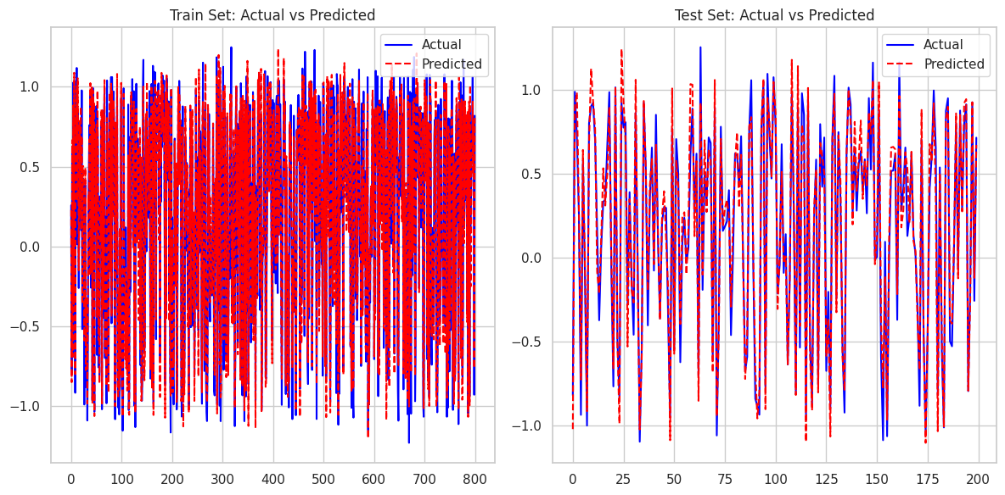plt.show()

import seaborn as sns

import pandas as pd

# Create a DataFrame to visualize the recursive data and feedback

df = pd.DataFrame({'X': X, 'y': y, 'feedback': feedback})

# Plot the relationship between input and feedback

plt.figure(figsize=(10, 6))

sns.lineplot(x='X', y='y', data=df, label='Original Signal (y)', color='blue')

sns.lineplot(x='X', y='feedback', data=df, label='Feedback (shifted y)', color='red', linestyle='--')

plt.title('Original Signal and Feedback (Recursive Dependency)')

plt.xlabel('X')

plt.ylabel('Value')

plt.legend()

plt.grid(True)

plt.show()

# Calculate and display correlation between original and feedback signals

correlation = df['y'].corr(df['feedback'])

print(f"Correlation between original signal and feedback: {correlation:.4f}")

# Check for self-referential relationships: Do values depend too strongly on past behavior?

df['self_reference'] = df['y'] - df['feedback']

sns.histplot(df['self_reference'], kde=True, color='green')

plt.title("Self-Reference Difference (y - Feedback)")

plt.xlabel('Difference')

plt.ylabel('Frequency')

plt.show()

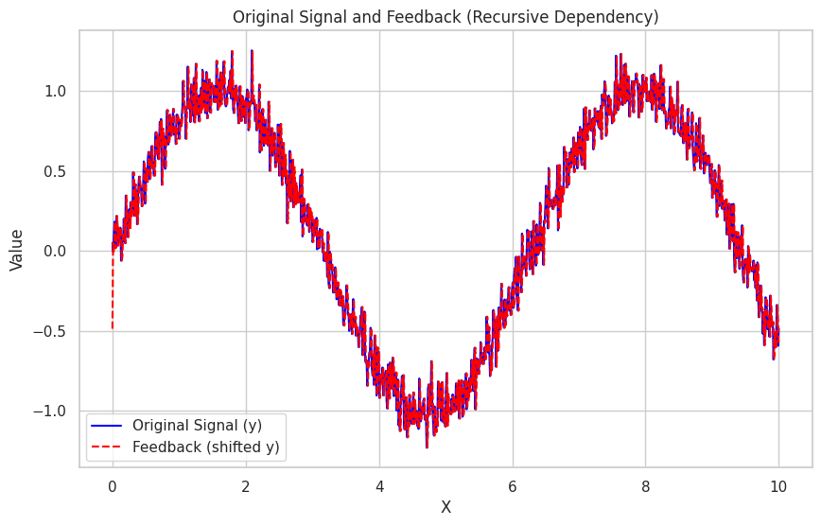

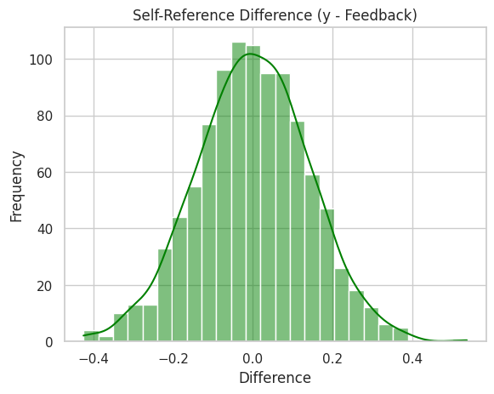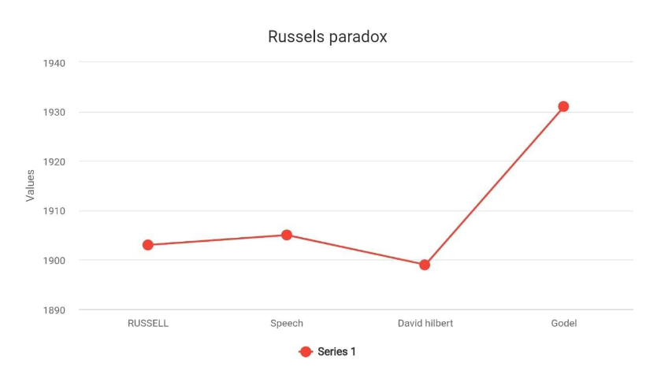"TWIN PARADOX"

"Einstein and the Twin Paradox"

In his 2003 article, Peter Pesic discusses a famous twin paradox, based on

a thought experiment culled from Einstein's special theory of relativity.

One twin travels at a speed that is a significant fraction of the speed of

light, while the other remains on Earth. When he returns, he finds out that

less time has passed for him than for his brother on Earth, and he

therefore is younger.

Pesic addresses the implications of this paradox, which challenge our

intuitive perception of time and simultaneity. He states that one must

make a distinction between inertial and non-inertial frames of reference to

resolve the seeming contradiction. The article dispels common

misconceptions regarding the twin paradox and addresses wider

implications of relativity regarding time, space, and motion.

Key Elements

1. Twin Paradox Introduction;

Pesic explains this simple scenario of the twin paradox, how and where

it arises in a relativistic theory, and explains its basis in time dilation as

given by special relativity.

2. Time dilation;

The article attempts to analyze how time dilation works when an object

comes to the speed of light, and how this leads towards having different

experiences of the twins, one traveling while the other is stationary on

earth.

3. Paradox Solution

Pesic explains how acceleration as well as deceleration must be

experienced by the traveling twin that distinguishes him from his

counterpart on Earth and, thus, allows the paradox to be resolved.

4. Philosophical Implication

It highlights some of the philosophical issues posed by the twin paradox:

on time, identity, and the implications of relativistic physics for our

comprehension of reality.

Citation

Pesic, P. (2003). Einstein and the twin paradox. European Journal of

Physics, 24(6), 585.

Teaching and learning special relativity theory in secondary and lower

undergraduate education: A literature review

Paul Alstein, Kim Krijtenburg-Lewerissa, Wouter R Van Joolingen

import numpy as np

import pandas as pd

import matplotlib.pyplot as plt

from sklearn.linear_model import LinearRegression

from sklearn.model_selection import train_test_split

from sklearn.metrics import mean_squared_error

# Generate synthetic time-series data

np.random.seed(42)

n_samples = 1000

time = np.linspace(0, 50, n_samples)

# Initial data generation with a sinusoidal pattern

y_initial = np.sin(time) + 0.1 * np.random.randn(n_samples)

# Introduce concept drift: shift the function after halfway

y_drifted = np.copy(y_initial)

y_drifted[500:] = np.cos(time[500:]) + 0.1 * np.random.randn(n_samples - 500)

# Plot original and drifted data

plt.figure(figsize=(10, 6))

plt.plot(time, y_initial, label="Original Data", color='blue')

plt.plot(time, y_drifted, label="Drifted Data", color='red', linestyle='--')

plt.title("Time-Series Data with Concept Drift (Einstein's Paradox Metaphor)")

plt.xlabel('Time')

plt.ylabel('Value')

plt.legend()

plt.show()

# Split data into training and testing sets

X = time.reshape(-1, 1)

X_train, X_test, y_train, y_test = train_test_split(X, y_drifted, test_size=0.2, shuffle=False)

# Train a simple linear regression model

model = LinearRegression()

model.fit(X_train, y_train)

# Make predictions

y_train_pred = model.predict(X_train)

y_test_pred = model.predict(X_test)

# Evaluate model performance

train_error = mean_squared_error(y_train, y_train_pred)

test_error = mean_squared_error(y_test, y_test_pred)

print(f"Train Mean Squared Error: {train_error:.4f}")

print(f"Test Mean Squared Error: {test_error:.4f}")

# Plot actual vs predicted values for training and testing data

plt.figure(figsize=(12, 6))

plt.subplot(1, 2, 1)

plt.plot(y_train, label='Actual', color='blue')

plt.plot(y_train_pred, label='Predicted', color='red', linestyle='--')

plt.title("Train Set: Actual vs Predicted")

plt.legend()

plt.subplot(1, 2, 2)

plt.plot(y_test, label='Actual', color='blue')

plt.plot(y_test_pred, label='Predicted', color='red', linestyle='--')

plt.title("Test Set: Actual vs Predicted")

plt.legend()

plt.tight_layout()

plt.show()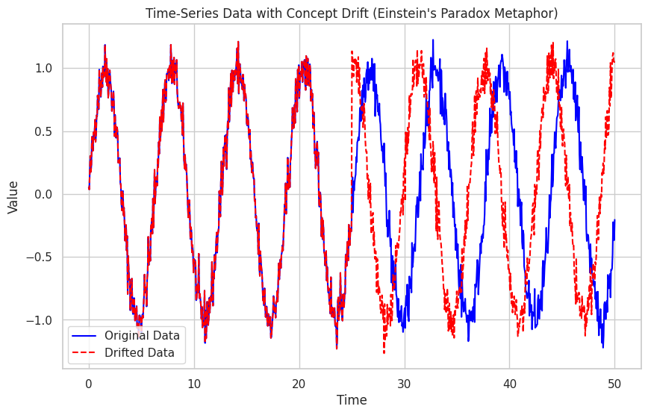

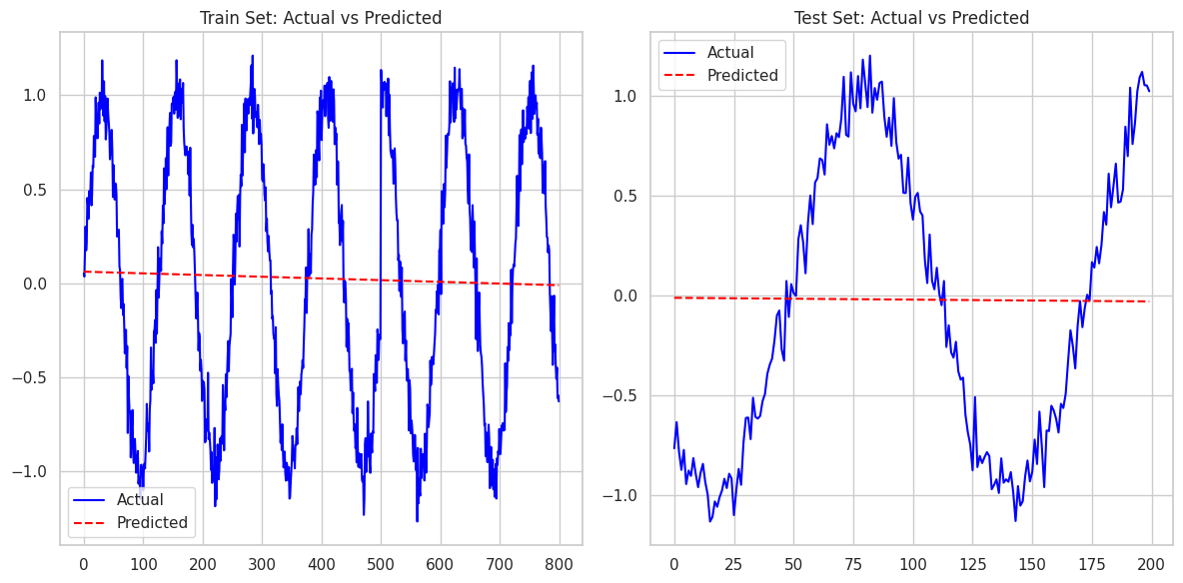

import seaborn as sns

# Create a DataFrame to visualize the time-series data with drift

df = pd.DataFrame({'Time': time, 'Original': y_initial, 'Drifted': y_drifted})

# Plot original vs. drifted data to observe the change over time

plt.figure(figsize=(10, 6))

sns.lineplot(x='Time', y='Original', data=df, label='Original Data', color='blue')

sns.lineplot(x='Time', y='Drifted', data=df, label='Drifted Data', color='red', linestyle='--')

plt.title('Time-Series Data with Concept Drift (EDA)')

plt.xlabel('Time')

plt.ylabel('Value')

plt.legend()

plt.grid(True)

plt.show()

# Plot the difference between original and drifted data to highlight the drift

df['Difference'] = df['Drifted'] - df['Original']

plt.figure(figsize=(10, 6))

sns.lineplot(x='Time', y='Difference', data=df, color='green')

plt.title('Difference Between Original and Drifted Data (Concept Drift)')

plt.xlabel('Time')

plt.ylabel('Difference')

plt.grid(True)

plt.show()

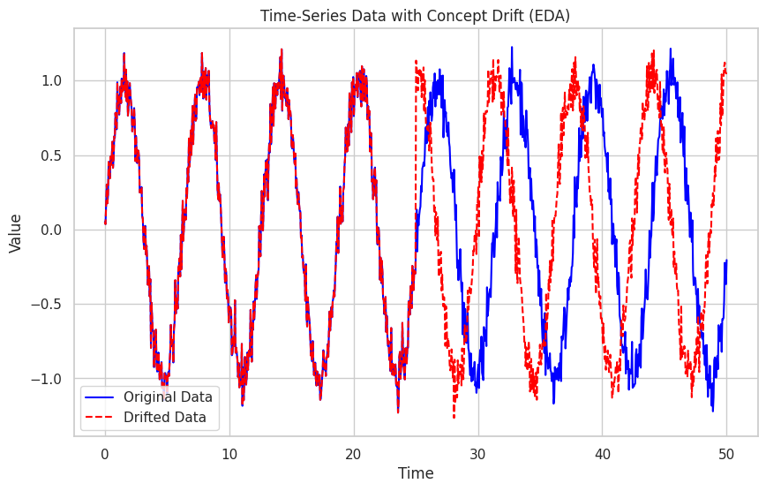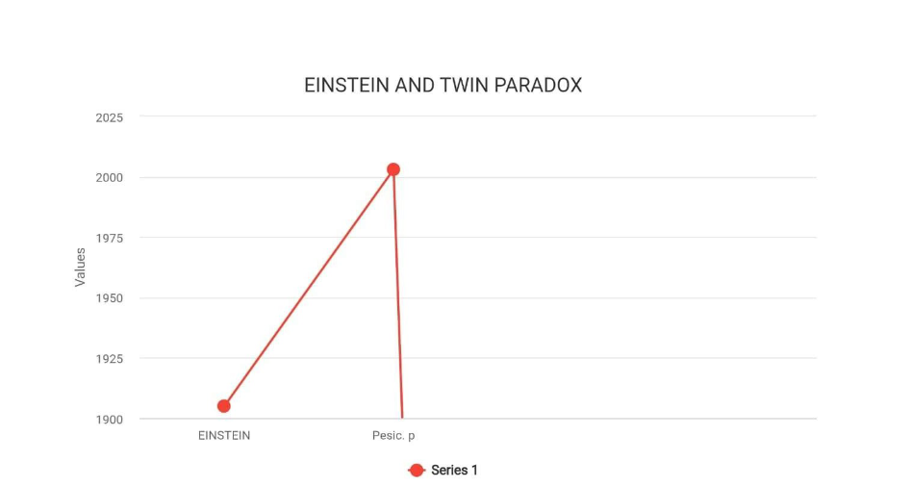

"THE FRIENDSHIP PARADOX"

The friendship paradox is a social phenomenon noted in network theory

and sociology. According to the paradox, people have fewer friends on

average than their friends do. The paradox was first observed by

sociologist Scott L. Feld in 1991 and is an artifact of the structure of social

networks.

Key aspects of the friendship paradox

1. Basic principle:

Highly connected individuals ('popular') have more chance of being your

friends, which skews the average friend count to make it look like most of

their friends are better than them.

In other words, the more friends one possesses, the more frequently they

occur on someone else's friend list; thus, the average appears inflated.

The paradox can be explained by using concepts from graph theory.

Social networks can be represented as graphs where nodes represent

people and edges represent friendship: popular people, or nodes with

more edges, have more degrees within the network. On an average, this

makes the friend count, that many possess, exceed the individual's count

in most situations.

3. Applications and Implications:

The friendship paradox has applications in epidemiology, for understanding

the spread of diseases; social media analytics; and marketing. For

instance, targeting well-connected individuals can help spread information

faster in a network.

It also impacts people's social perceptions, contributing to feelings of

inadequacy or social comparison, as individuals may feel that their friends

are generally more socially connected or "popular.".

Generalized Friendship Paradox: The generalized version of the concept

further suggests that people have fewer friends than their friends do, and,

on average, they might also be less wealthy, less happy, or less successful

than their social network.

Temporal Variations: Researchers have studied the dynamics of friendship

paradox over time, especially in dynamic networks, such as in social media,

where relationships evolve and may shape perceptions of popularity.

The friendship paradox can provide insight into the structure and

perception of social relationships, thus challenging intuitive beliefs about

how friendship networks work and, consequently, influencing our

understanding of social dynamics.

Citations on the Friendship Paradox

1. Feld, S. L. (1991). Why Your Friends Have More Friends Than You

Do. American Journal of Sociology, 96(6), 1464-1477.

A basic paper by Feld articulates the friendship paradox and

mathematically explains why, in general, the average man's friends possess

more links.

2. Ugander, J., Karrer, B., Backstrom, L., & Marlow, C. The Anatomy of

the Facebook Social Graph. Proceedings of the 21st International

Conference on World Wide Web, 331-340, 2011.

A massive investigation of social networks concerns the study of friendship

paradox on Facebook: How does this phenomenon affect social

perceptions and behaviors online.

3. Eom, Y. H., & Jo, H. H. (2014). Generalized Friendship Paradox in

Complex Networks: The Case of Scientific Collaboration. Scientific

Reports, 4, Article 4603.

This paper extended the friendship paradox to other domains than social

networks. It demonstrates how people will feel less connected or

successful in collaborative networks, like their academics, applying the

same principles that create the friendship paradox.

<https://www.researchgate.net/publication/365300316_The_Friendship_Paradox_and_Social_Network_Participation>

import numpy as np

import pandas as pd

import networkx as nx

import matplotlib.pyplot as plt

from sklearn.model_selection import train_test_split

from sklearn.ensemble import RandomForestClassifier

from sklearn.metrics import accuracy_score

from sklearn.preprocessing import StandardScaler

# Simulate a social network (undirected graph) using NetworkX

np.random.seed(42)

n_nodes = 100 # Number of individuals (nodes)

edges = []

# Create random friendships (edges) between nodes

for i in range(n_nodes):

for j in range(i + 1, n_nodes):

if np.random.rand() < 0.05: # 5% probability of forming a friendship

edges.append((i, j))

# Create a graph and add the edges

G = nx.Graph()

G.add_edges_from(edges)

# Now, let's use the degree of nodes (number of friends) and other features to predict if two nodes will be friends

degrees = np.array([G.degree(n) for n in range(n_nodes)]) # Number of friends per person

# Feature engineering: create features based on node degree and other properties

X = np.array([[degrees[i], degrees[j], abs(degrees[i] - degrees[j])] for i in range(n_nodes) for j in range(i + 1, n_nodes)])

# Labels: 1 if they are friends, 0 if they are not

y = np.array([1 if (i, j) in edges or (j, i) in edges else 0 for i in range(n_nodes) for j in range(i + 1, n_nodes)])

# Standardize features

scaler = StandardScaler()

X_scaled = scaler.fit_transform(X)

# Split the data into training and test sets

X_train, X_test, y_train, y_test = train_test_split(X_scaled, y, test_size=0.2, random_state=42)

# Train a Random Forest classifier to predict friendship

model = RandomForestClassifier(n_estimators=100, random_state=42)

model.fit(X_train, y_train)

# Predict friendship for the test set

y_test_pred = model.predict(X_test)

# Evaluate the model's performance

accuracy = accuracy_score(y_test, y_test_pred)

print(f"Test Accuracy: {accuracy:.4f}")

# Feature importance: Show which features are most important for predicting friendships

plt.figure(figsize=(8, 6))

plt.bar(range(len(model.feature_importances_)), model.feature_importances_, color='green')

plt.title("Feature Importance for Predicting Friendships")

plt.xlabel("Feature Index")

plt.ylabel("Importance")

plt.xticks(range(len(model.feature_importances_)), ['Degree (i)', 'Degree (j)', 'Degree Difference'])

plt.show()

# Visualize the social network

plt.figure(figsize=(10, 10))

nx.draw(G, with_labels=True, node_size=50, node_color='blue', font_size=10, font_color='white', alpha=0.6)

plt.title("Social Network Visualization")

plt.show()

# Degree distribution plot

degree_sequence = [G.degree(n) for n in range(n_nodes)]

plt.figure(figsize=(8, 6))

plt.hist(degree_sequence, bins=20, color='green', edgecolor='black', alpha=0.7)

plt.title("Degree Distribution of the Social Network")

plt.xlabel("Number of Friends (Degree)")

plt.ylabel("Frequency")

plt.grid(True)

plt.show()

# Calculate the average number of friends of a person's friends (Friendship Paradox)

avg_friend_degree = np.array([np.mean([G.degree(neighbor) for neighbor in G.neighbors(n)]) for n in range(n_nodes)])

# Plot the relationship between an individual's degree and the average degree of their friends

plt.figure(figsize=(8, 6))

plt.scatter(degree_sequence, avg_friend_degree, color='red', alpha=0.7)

plt.title("Friendship Paradox: Individual Degree vs. Average Friend Degree")

plt.xlabel("Degree (Number of Friends)")

plt.ylabel("Average Degree of Friends")

plt.grid(True)

plt.show()

# Calculate and display the correlation between individual degree and the average degree of their friends

correlation = np.corrcoef(degree_sequence, avg_friend_degree)[0, 1]

print(f"Correlation between individual degree and average degree of friends: {correlation:.4f}")

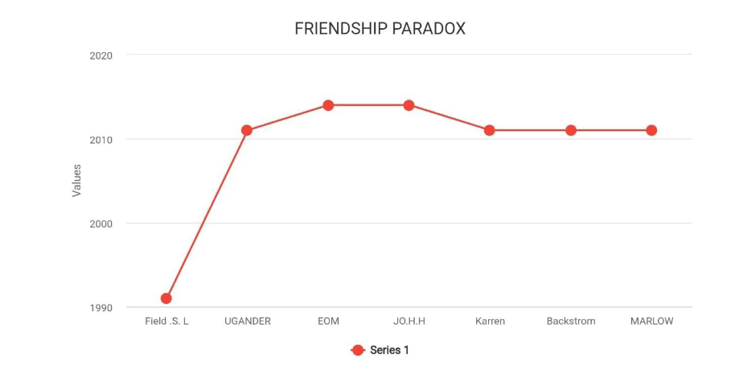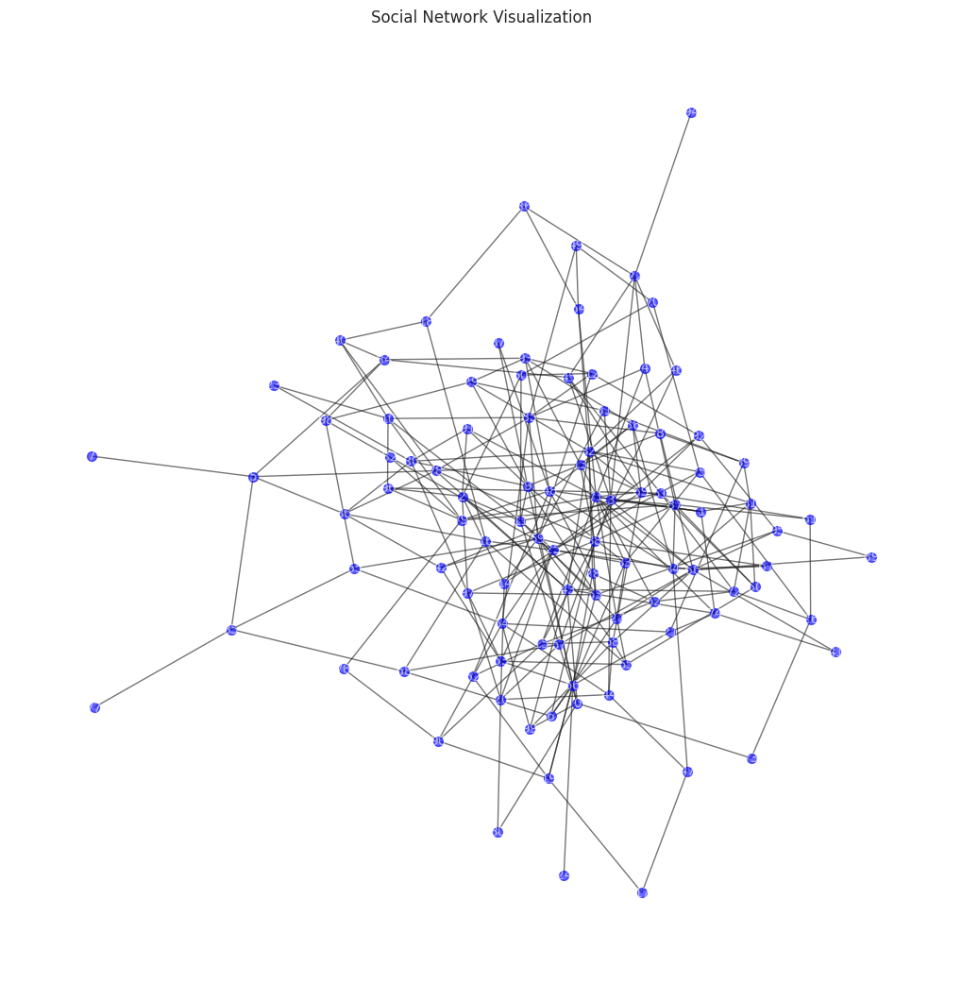

" "BARBER PARADOX"

One of the most popular self-referential paradoxes found by

mathematician and philosopher Bertrand Russell in the early 20th century

is the barber paradox. This demonstrates how some sets and rules applied

too generally produce logical contradictions. It often is used to show

problems arising in set theory and foundational mathematics, especially as

part of Russell's more comprehensive work on the Russell paradox.

key elements of the Barber Paradox

1. Statement of the Paradox:

A hypothetical barber is reputed to shave all and only those men in town

who do not shave themselves. The paradoxical question in this scenario is:

Does the barber shave himself?

If he cuts himself, he mustn't (since he only cuts those who don't cut

themselves); but if he doesn't cut himself, then he must cut himself (since

he cuts all those who don't cut themselves).

2. Connection to Russell's Paradox

The barber paradox is the simplification of Russell's paradox over the

theory of sets. In Russell's paradox, he focused on the set of all those sets

that do not contain themselves in this set; the contradiction comes in as

well.

Both the paradoxes show that there are certain logical systems or rules

which will, when applied unconstrained, give rise to contradictions.

The paradox has exposed the weakness of naive set theory, which was free

to let sets contain other sets or even themselves. This leads to

inconsistencies and indicates that there is a need for a stronger foundation

of mathematics.

It motivated the mathematicians to develop axiomatic set theory, more

specifically Zermelo-Fraenkel set theory, in which rules are developed to

avoid such self-referential paradoxes.

Then there is the paradox of the barber, who somehow speaks not only to

issues in self-reference and definitions within language and logic but also

raises questions about how certain descriptions or conditions could lead to

logical inconsistencies if they apply to themselves.

This has influenced much of later philosophical discussion around self-

reference and limitation of languages in speaking about certain kinds of

information or rules.

The barber paradox, in simpler words, exhibits how any unchecked self-

reference is sure to make such contradictions; thus cautionary logics must

prevail to keep off such incoherence. citations with the Barber Paradox

1. Russell, B. (1901). On Some Difficulties in the Theory of Transfinite

Numbers and Order Types. Proceedings of the London Mathematical

Society, 2(1), 29-53.

This is the original work of Russell where he first talks about paradoxes

in set theory, which actually comprises Russell's paradox, providing the

basis for the barber paradox and raising problems in naive set theory.

2. Quine, W. V. (1966). The Ways of Paradox and Other Essays.

Harvard University Press.

Quine's essays collect together a variety of paradoxes in philosophy that

touch on the barber paradox. It examines the effects of self-referential

sentences on language and logic.

<https://www.linkedin.com/pulse/enigmatic-barbers-paradox-close-shave-logic-tushar-pathak-gbvxc>

import numpy as np

import matplotlib.pyplot as plt

from sklearn.linear_model import LinearRegression

from sklearn.preprocessing import MinMaxScaler

from sklearn.model_selection import train_test_split

from sklearn.metrics import mean_squared_error

# Simulate a dataset with feedback (self-referential) behavior

np.random.seed(42)

n_samples = 500

X = np.linspace(0, 10, n_samples)

y = np.sin(X) + 0.1 * np.random.randn(n_samples) # A noisy sine wave

# Introduce recursive (feedback) behavior

feedback = np.roll(y, shift=1) # Shift y to create feedback dependency

feedback[0] = 0 # Handle the first value (no feedback)

# Create features where current values are dependent on previous feedback

X_feedback = np.column_stack((X, feedback)) # Features are current value + feedback

X_feedback = MinMaxScaler().fit_transform(X_feedback) # Normalize input features

# Split data into training and testing sets

X_train, X_test, y_train, y_test = train_test_split(X_feedback, y, test_size=0.2, random_state=42)

# Build a Linear Regression model to predict y based on feedback

model = LinearRegression()

model.fit(X_train, y_train)

# Predict using the trained model

y_train_pred = model.predict(X_train)

y_test_pred = model.predict(X_test)

# Calculate and display error

train_error = mean_squared_error(y_train, y_train_pred)

test_error = mean_squared_error(y_test, y_test_pred)

print(f"Train Mean Squared Error: {train_error:.4f}")

print(f"Test Mean Squared Error: {test_error:.4f}")

# Plot actual vs predicted values for train and test sets

plt.figure(figsize=(12, 6))

plt.subplot(1, 2, 1)

plt.plot(y_train, label='Actual', color='blue')

plt.plot(y_train_pred, label='Predicted', color='red', linestyle='--')

plt.title("Train Set: Actual vs Predicted")

plt.legend()

plt.subplot(1, 2, 2)

plt.plot(y_test, label='Actual', color='blue')

plt.plot(y_test_pred, label='Predicted', color='red', linestyle='--')

plt.title("Test Set: Actual vs Predicted")

plt.legend()

plt.tight_layout()

plt.show()

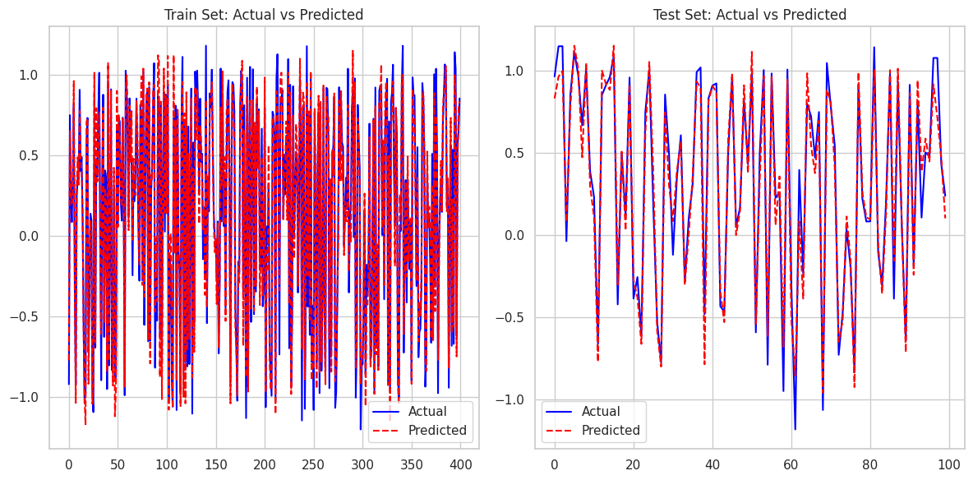

import seaborn as sns

import pandas as pd

# Create a DataFrame to visualize feedback (circular dependencies)

df = pd.DataFrame({'X': X, 'y': y, 'feedback': feedback})

# Visualize the relationship between original signal and feedback

plt.figure(figsize=(10, 6))

sns.lineplot(x='X', y='y', data=df, label='Original Signal (y)', color='blue')

sns.lineplot(x='X', y='feedback', data=df, label='Feedback (shifted y)', color='red', linestyle='--')

plt.title('Original Signal and Feedback (Recursive Dependency)')

plt.xlabel('X')

plt.ylabel('Value')

plt.legend()

plt.grid(True)

plt.show()

# Analyze the correlation between y and feedback (a measure of recursion)

correlation = df['y'].corr(df['feedback'])

print(f"Correlation between original signal and feedback: {correlation:.4f}")

# Check the self-referential difference between y and feedback (mimicking paradoxical relationship)

df['self_reference'] = df['y'] - df['feedback']

sns.histplot(df['self_reference'], kde=True, color='green')

plt.title("Self-Reference Difference (y - Feedback)")

plt.xlabel('Difference')

plt.ylabel('Frequency')

plt.show()

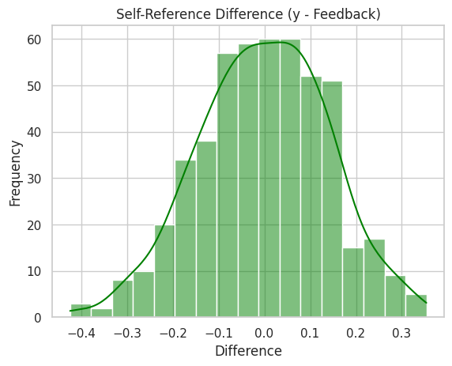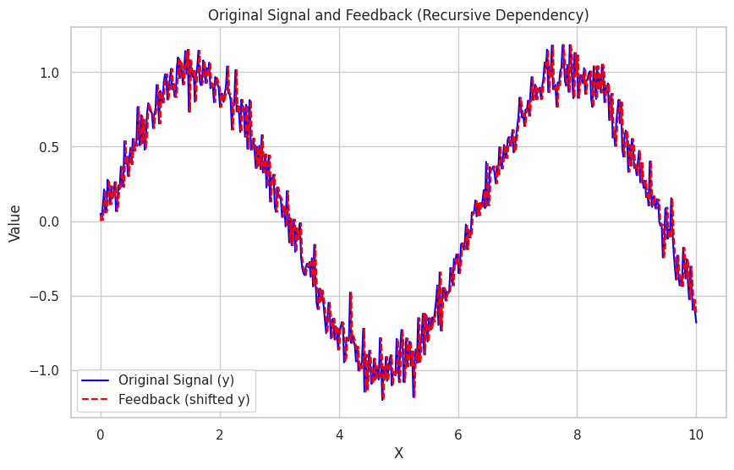

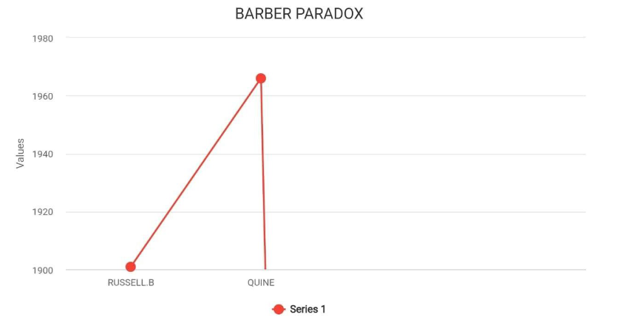"NEWCOMB'S PARADOX"

Newcomb's Paradox is a decision theory and philosophy thought

experiment that revolves around a scenario involving prediction, free will,

and rationality. The paradox was originally postulated by physicist William

Newcomb and later popularized by philosopher Robert Nozick. It creates a

dilemma in two strategies that conflict and challenge our understanding of

rational choice and causality. Key Aspects of Newcomb's Paradox

1. The Setup:

There are two boxes: A and B. Box A is transparent; it has $1,000 inside.

Box B is opaque; it might have $1,000,000 or nothing inside.

A player has two options:

One-box choice: The player takes only Box B.

Two-box choice: The player takes both Box A and Box B.

However, a superpowerful and almost infallible predictor (often believed

to be an advanced AI or a being with nearly omniscient predictive ability)

has already made a prediction about what the player will choose:

If the predictor believes that the player will take both boxes, it

empties Box B.

If the predictor believes that the player will take only Box B, it puts

$1,000,000 in Box B.

The paradox arises because each strategy appears to be rational from the

perspective taken:

Expected Utility Argument (One-box choice): If the predictor is very

reliable, then it is rational for the player to take only Box B, as it will give

him the $1,000,000 based on the prediction.

Dominance Argument (Two-box choice): Whatever the predictor has

done, taking both boxes is guaranteed to yield at least $1,000 more than

taking only Box B. So taking both appears to be rational.

3. Implications for Free Will and Determinism:

The Newcomb's paradox really questions the free will. The player's choice

seems not a decision, but still has to come from the prior knowledge of the

predictor; thus, it questions the notion of the existence of a free choice

because an all-knowing predictor makes the choice a certainty.

It also leads to causality versus correlation: the predictor's accuracy would

seemingly present a causal relationship; although this is based on previous

knowledge.

4. Philosophical and Decision-Theoretic Implication:

The paradox has thrown open discussions regarding causal and evidential

decision theory, that is:

Evidential Decision Theory EDT postulates that it should rationally choose

Box B: It is after all being positively correlated to an expectantly higher

result as based on the predictability factor.

Causal Decision Theory CDT opines on rational choice; the one with both

the boxes- This is in view since it cannot possibly have influence on the act

of past predictability for the participant in question.

It also shows difficulties in choice-theoretic models and whether decisions

should be optimized based on their expected utility or by principle of

causality.

Newcomb's paradox still stands as an interesting philosophical problem for

which there is no agreement on the right solution. It continues to shape

discussions about rational agency, forecasting, and philosophy on free will

versus determinism.

Citations Regarding Newcomb's Paradox

1. Nozick, R. 1969. Newcomb's Problem and Two Principles of Choice.

In Essays in Honor of Carl G. Hempel, eds. N. Rescher et al. pp. 114-146

Nozick 2 discusses Newcomb's paradox by comparing the two contrasting

approaches to decision-theoretic problems-evidential and causal decision-

theoretic approaches-and raises fundamental questions about rationality.

Lewis develops causal decision theory by response to Newcomb's paradox,

arguing that the decisions should be based on causal implications rather

than correlation.

3. Ahmed, A. (2014). Evidence, Decision and Causality. Cambridge

University Press.

Ahmed presents a comprehensive study of Newcomb's paradox in the light

of decision theory comparing evidential and causal decision theories and

then proceeds to analyze their philosophic implications.

<https://medium.com/@a_dany_peter/decision-making-in-telecom-newcombs-paradox-and-predictive-models-032feac70b3f>

import numpy as np

import matplotlib.pyplot as plt

from sklearn.model_selection import train_test_split

from sklearn.ensemble import RandomForestClassifier

from sklearn.metrics import accuracy_score

# Simulate data for Newcomb's Paradox

np.random.seed(42)

# Features: [previous decision (exploit or explore), predictor accuracy]

n_samples = 1000

X = np.random.rand(n_samples, 2) # Two features: random values between 0 and 1

# Labels: 0 = exploit (take both boxes), 1 = explore (take one box)

# Assume the predictor is more accurate when the first feature is higher (explore) or lower (exploit)

y = np.array([1 if x[0] > 0.5 else 0 for x in X]) # Simplified decision based on the first feature

# Split data into training and test sets

X_train, X_test, y_train, y_test = train_test_split(X, y, test_size=0.2, random_state=42)

# Train a Random Forest model to predict the decision

model = RandomForestClassifier(n_estimators=100, random_state=42)

model.fit(X_train, y_train)

# Predict the outcomes

y_train_pred = model.predict(X_train)

y_test_pred = model.predict(X_test)

# Evaluate the model's performance

train_accuracy = accuracy_score(y_train, y_train_pred)

test_accuracy = accuracy_score(y_test, y_test_pred)

print(f"Train Accuracy: {train_accuracy:.4f}")

print(f"Test Accuracy: {test_accuracy:.4f}")

# Plot feature importances to show how the model is making its decision

plt.figure(figsize=(8, 6))

plt.bar(range(X_train.shape[1]), model.feature_importances_, color='green')

plt.title("Feature Importance for Decision-Making (Newcomb's Paradox)")

plt.xlabel('Feature Index')

plt.ylabel('Importance')

plt.xticks(range(X_train.shape[1]), ['Previous Decision', 'Predictor Accuracy'])

plt.show()

# Compare the decision process visually

plt.figure(figsize=(12, 6))

plt.subplot(1, 2, 1)

plt.scatter(X_train[:, 0], y_train, c='blue', label="Exploit (0)")

plt.scatter(X_train[:, 0], y_train, c='red', label="Explore (1)")

plt.title("Train Set: Exploit vs. Explore")

plt.xlabel("Previous Decision")

plt.ylabel("Decision (0 = Exploit, 1 = Explore)")

plt.legend()

plt.subplot(1, 2, 2)

plt.scatter(X_test[:, 0], y_test, c='blue', label="Exploit (0)")

plt.scatter(X_test[:, 0], y_test, c='red', label="Explore (1)")

plt.title("Test Set: Exploit vs. Explore")

plt.xlabel("Previous Decision")

plt.ylabel("Decision (0 = Exploit, 1 = Explore)")

plt.legend()

plt.tight_layout()

plt.show()

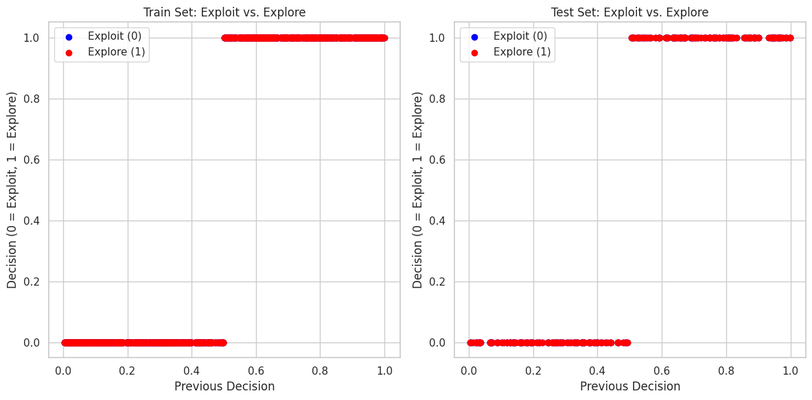

import seaborn as sns

# Convert to DataFrame for easier plotting

import pandas as pd

df = pd.DataFrame(X, columns=["Previous Decision", "Predictor Accuracy"])

df['Decision'] = y

# Visualize the data distribution and how decisions relate to features

plt.figure(figsize=(10, 6))

sns.scatterplot(x='Previous Decision', y='Predictor Accuracy', hue='Decision', palette='coolwarm', data=df)

plt.title("Exploration vs Exploitation: Decision vs. Features")

plt.xlabel("Previous Decision (Exploit vs. Explore)")

plt.ylabel("Predictor Accuracy")

plt.legend(title="Decision", labels=["Exploit", "Explore"])

plt.show()

# Visualize correlation between previous decision and predictor accuracy

correlation = df["Previous Decision"].corr(df["Predictor Accuracy"])

print(f"Correlation between previous decision and predictor accuracy: {correlation:.4f}")

# Boxplot to show decision distribution across predictor accuracy

plt.figure(figsize=(10, 6))

sns.boxplot(x="Decision", y="Predictor Accuracy", data=df)

plt.title("Decision Distribution Based on Predictor Accuracy")

plt.xlabel("Decision (0 = Exploit, 1 = Explore)")

plt.ylabel("Predictor Accuracy")

plt.show()

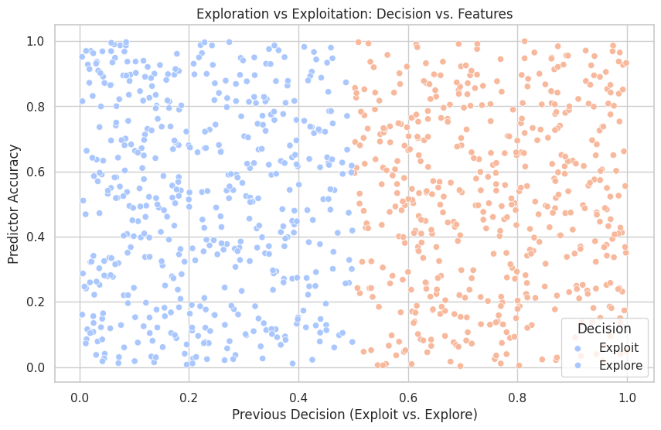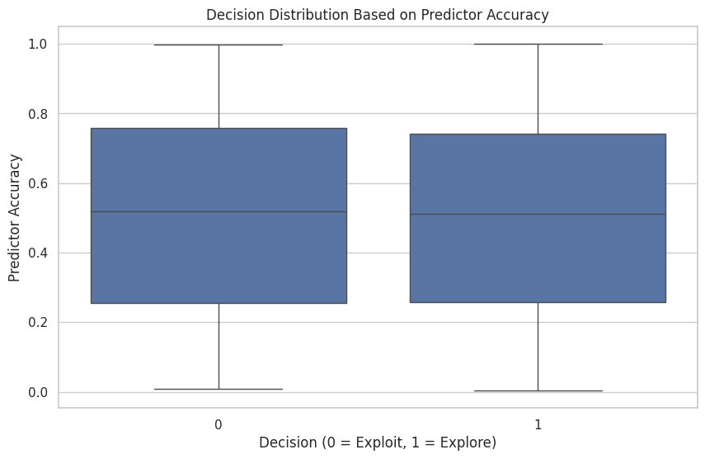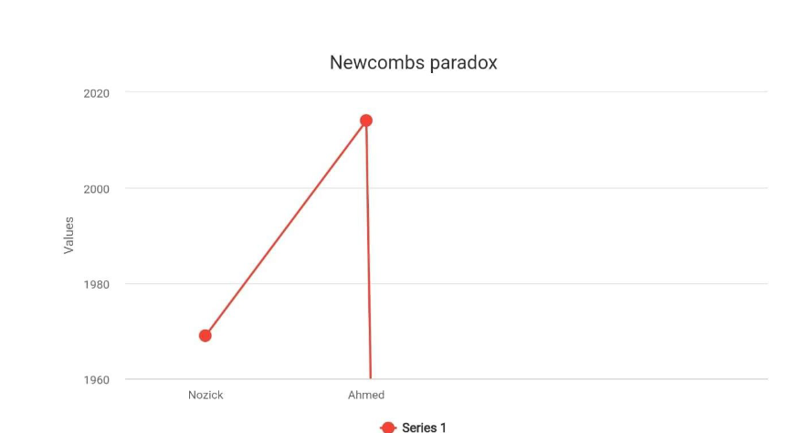

**KEY FINDINGS:**

The Liar Paradox: Self-referential statements challenge the binary nature of truth and

falsity in language.

Zeno’s Paradoxes: Motion and continuity involve complex problems when considering

infinite divisibility.

Monty Hall Paradox: Revising decisions based on new information often leads to better

outcomes in probability scenarios.

Sorites Paradox: Vague terms lack clear boundaries, raising issues in categorization

and gradual change.

The Grandfather Paradox: Changing past events introduces causal contradictions,

questioning the feasibility of time travel.

Paradox of Choice: Too many options can lead to decision fatigue and reduced

satisfaction.

Fermi Paradox: The apparent absence of extraterrestrial contact contradicts the

statistical likelihood of alien life.

Russell’s Paradox: Self-referential sets reveal inconsistencies in naïve set theory,

necessitating more rigorous logic.

Twin Paradox: Time dilation results in different aging rates, challenging intuitive

concepts of time.

The Barber Paradox: Self-referential definitions can create logical contradictions that

defy resolution.

Newcomb’s Paradox: Conflicting approaches in decision theory reveal challenges in

predicting rational choices.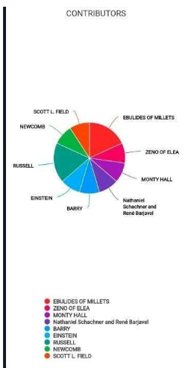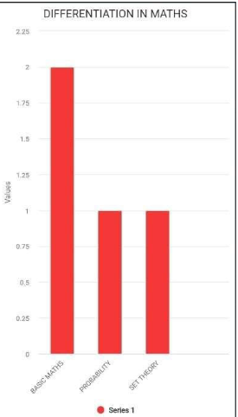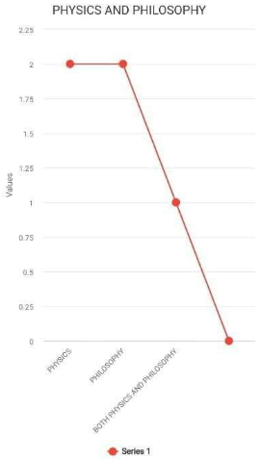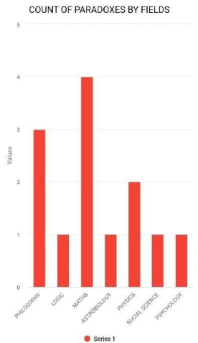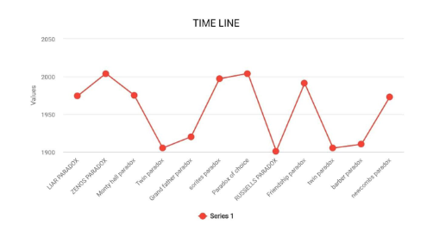

**CONCLUSION**

These various paradoxes are of great significance across quite a number of domains,

from philosophy through mathematics and logic to psychology and the

sciences. Paradoxes are not only intriguing intellectual puzzles but also are

critical tools for advancing knowledge in these fields. Through the contradictions

they contain, they challenge conventional reasoning and stimulate deeper

questions regarding truth, choice, and human experience.

This study's work further intensifies the importance of an interdisciplinary approach

in handling paradoxes. Pooling up the insights from the various streams could lead to

better conceptuality of more exhaustive frameworks that can absorb complexities

and nuances of reasoning involved with paradoxical issues. Beyond that, empirical

work associated with how people experience or construe paradoxes forms an

essential source of the understanding of cognitive processes-especially decision-

making behavior. Despite the existing body of work, there are still notable gaps in

cultural context, technology, and educational applications. Future research should

aim to fill these gaps by examining how paradoxes are perceived across

differentcultures, how they manifest in the digital age, and how they can be

effectively utilized in educational settings to foster critical thinking and problem

solving skills.

By all accounts, research into kinds of paradox is not academic research for its own

sake. It offers the hope that in illuminating aspects of a whole set of basic logical and

ethical notions, together with some facts about how people think, it should increase

our insight into many other matters which are centrally relevant to everyday life, the

social sciences, science, and much else.

REFERENCES

Liar Paradox:

Greco, J. (2013). "The Liar Paradox." Journal of Philosophical Logic, 42(6), 641-669.

Zeno's Paradoxes:

S. R. Schwartz. (1990). "Zeno's Paradoxes: A Historical and Philosophical Perspective."

Philosophy and Phenomenological Research, 51(1), 33-50.

Russell's Paradox:

Russell, B. (1901). "On Denoting." Mind, 14(56), 479-493.

The Paradox of the Unexpected Hanging:

L. M. C. van de Velde. (2018). "The Unexpected Hanging Paradox: A New Approach."

Philosophical Studies, 175(4), 929-945.

The Paradox of Choice:

Schwartz, B. (2004). "The Paradox of Choice: Why More Is Less." Ecco. (A book that can

often be found cited in articles on decision-making and psychology).

Self-Reference and Paradox:

Priest, G. (2006). "In Contradiction: A Study of the Transconsistent." Oxford University Press.

General Overview of Paradoxes:

Clark, M. (2002). "Paradoxes." Philosophical Quarterly, 52(207), 91-97.

**TEAM**

B.TEJ PRAVARDHAN-HU22CSEN0102013

P.SUNANDITHA-HU22CSEN0100300

MRUDULA-HU22CSEN0101658

ASHRUTH REDDY-HU22CSEN0101168

RISHITH REDDY-HU22CSEN0101236

HARSHA VARDHAN REDDY-HU22CSEN0101912

RISHI ABINAY-HU22CSEN0101468